DELIVERY ARRANGEMENT (11)
Dated: Sept.24, 2024
- Shipping mark: SNAT, 1 package, case No. 678
Estimated arrival date in Kathmandu: Sept.20
Deliver to the following, collecting nothing
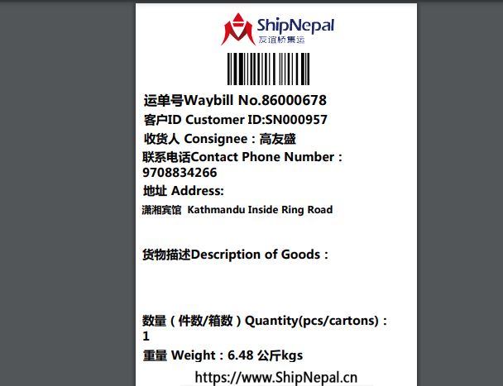

- Shipping mark: MUDP, 3 packages, case No. 679-1-2-3
Estimated arrival date in Kathmandu: Sept. 29
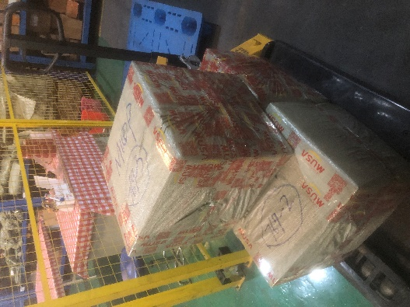
Transship to Pokhara, address to be decided, will inform once arrived collecting nothing
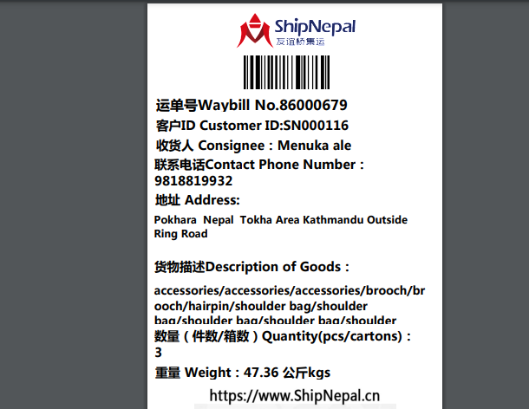

- Shipping mark: UPAT, 4 packages, case No. 681-1-2-3-4
Estimated arrival date in Kathmandu: Sept. 25
Deliver to the following, collecting customs fees
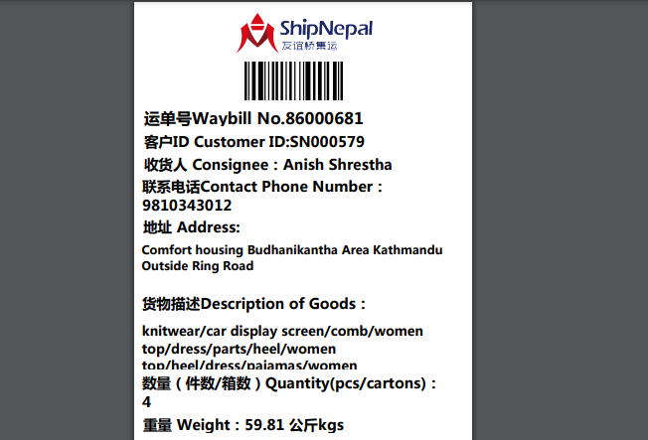
- shipping mark: MUDP, 1 package, case No. 687
Estimated arrival date in Kathmandu: Sept.30
Deliver to the following, collecting nothing
