DELIVERY ARRANGEMENT (10)
Dated: Sept.2, 2024
- Shipping mark: UPAT, 1 package, case No. 659
Estimated arrival date in Kathmandu: Sept.5
Deliver to the following, collecting customs fees
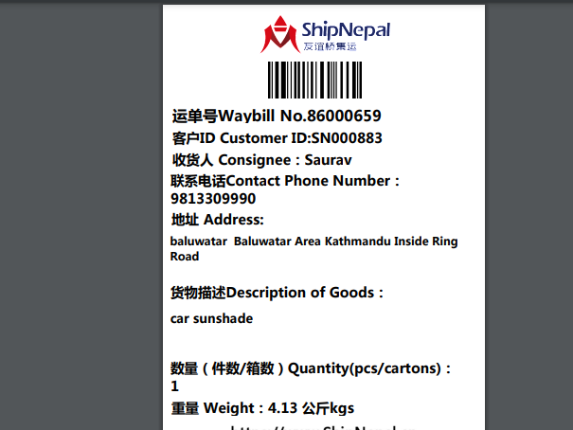

- Shipping mark: UMDP, 4 package, case No. 656-1-2-3-4
Estimated arrival date in Kathmandu: Sept. 10
Open the case No. 656-4, shown as below, including 3 customers
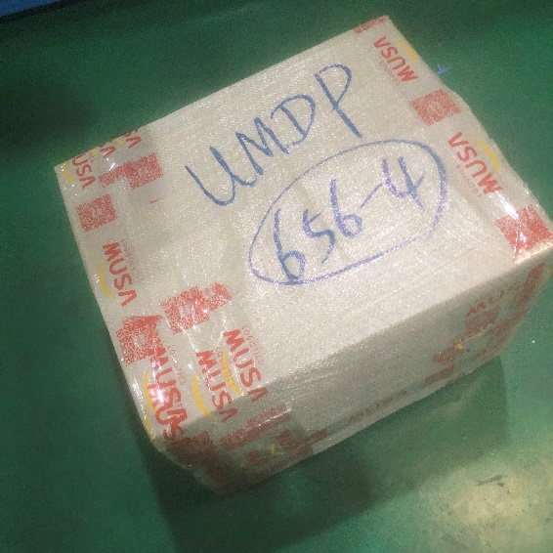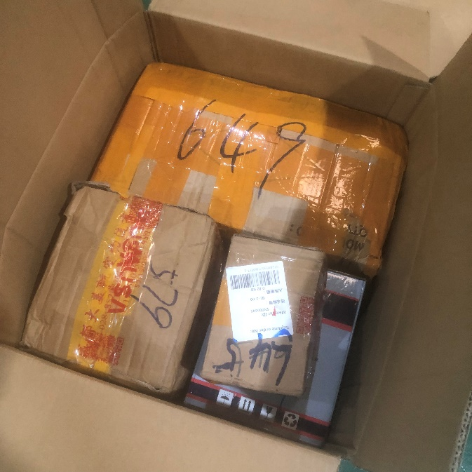
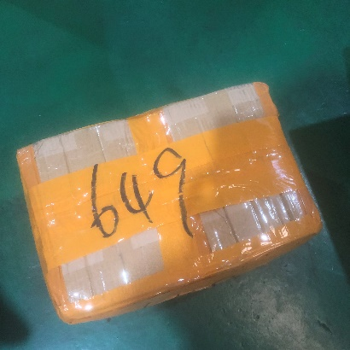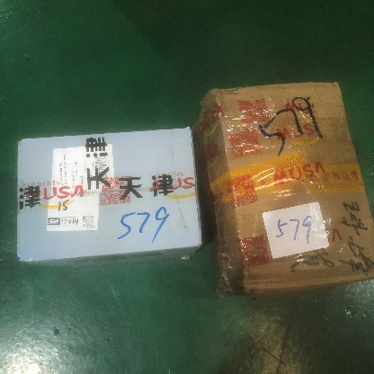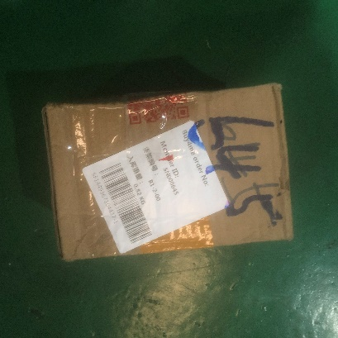

Deliver 649 (1 box) to the following, collecting nothing
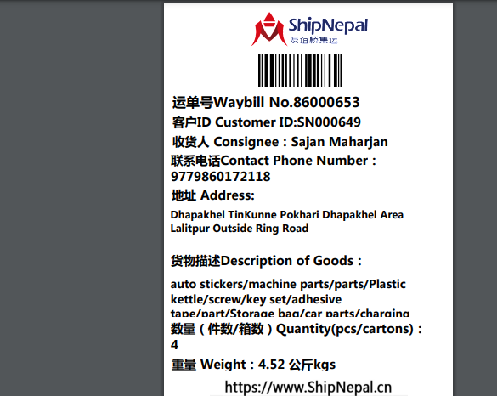
Deliver 579 (2 boxes) to the following, collecting nothing
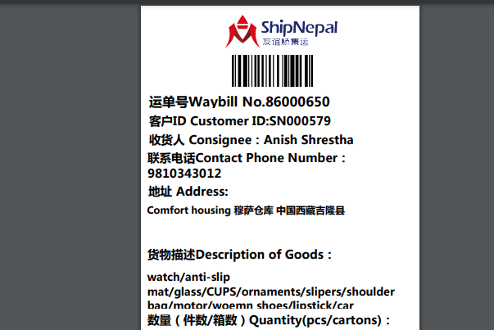

Deliver 645 (1 small box) to SN000645
Deliver case No.645-1-2-3 (3 whole packages) to the following, collecting customs fees
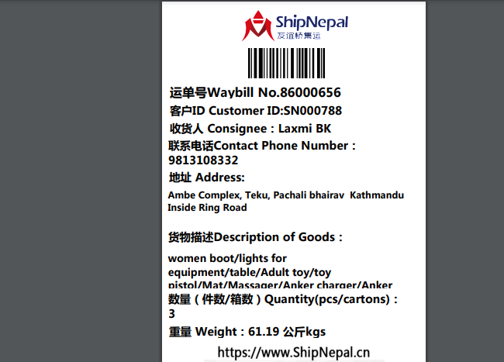

- Shipping mark: POAT, 2 packages, case No. 665-1-2
Estimated arrival date in Kathmandu: Sept.9
Deliver the rest to the following, collecting nothing
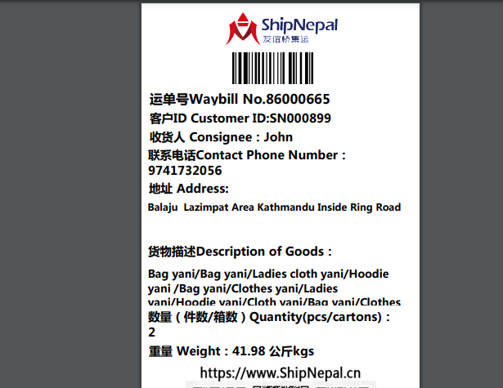

- Shipping mark: POAT, 2 packages, case No. 667-1-2
Estimated arrival date in Kathmandu: Sept.10
Open Case No.667-2, shown as below
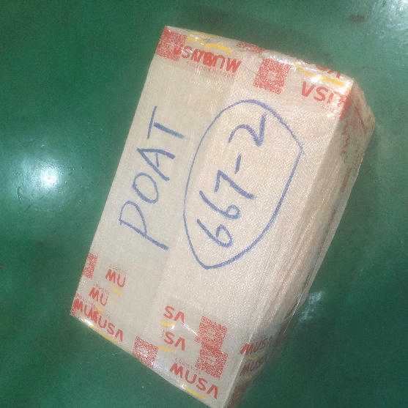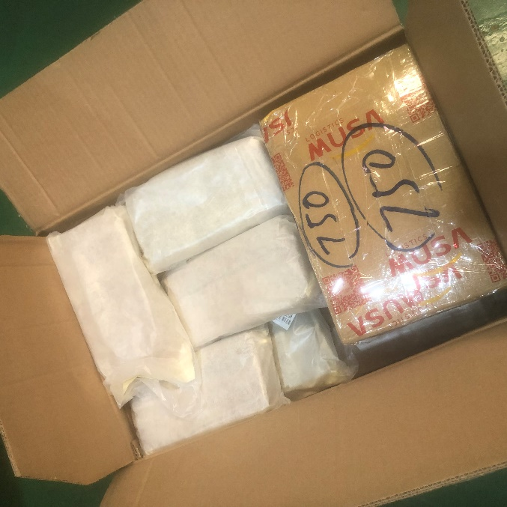
Taking out box 750, deliver to the following, collecting nothing
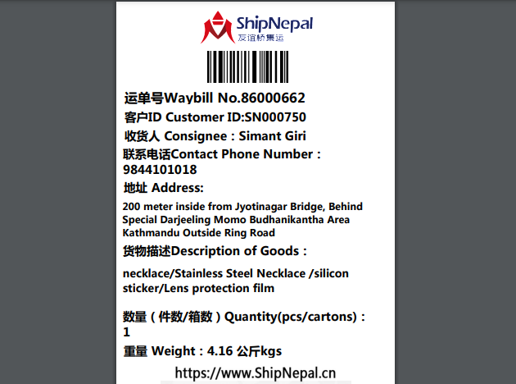

Deliver Case No. 667-1 and the rest of 667-2 to the following, collecting nothing
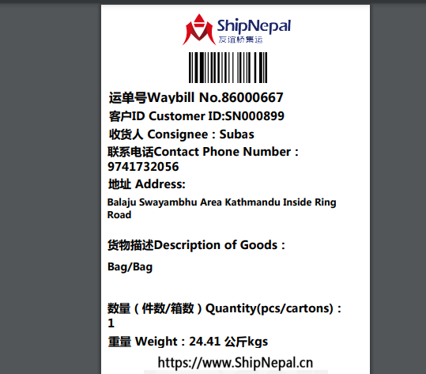
- Shipping mark: MUDP, 1 packages, case No. 668
Estimated arrival date in Kathmandu: Sept.19
Deliver to the following, collecting nothing
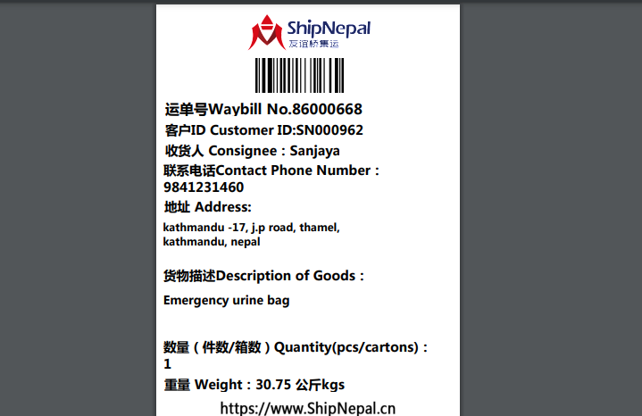

- Shipping mark: UMDP, 4 package, case No. 673-1-2-3-4
Estimated arrival date in Kathmandu: Sept. 19
Open the case No. 673-4, shown as below
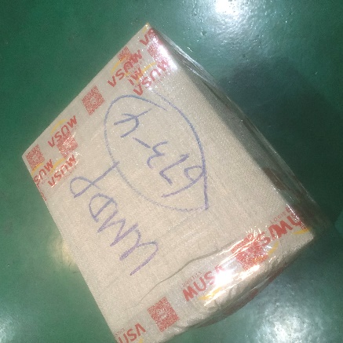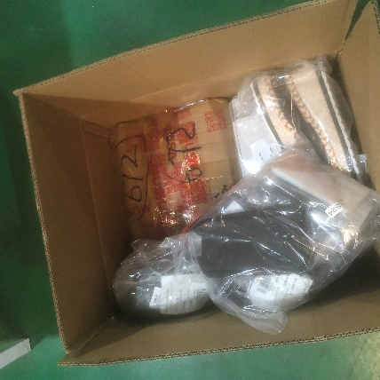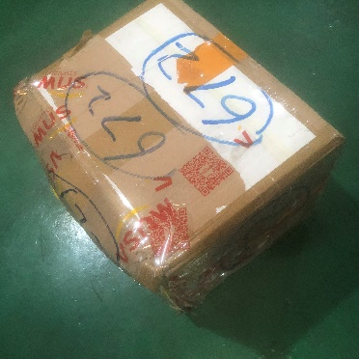
Taking out the box 672, ask Candy to offer you the corresponding PL in order to issue separate cusotms bill, colecting customs fees separately from the following customer
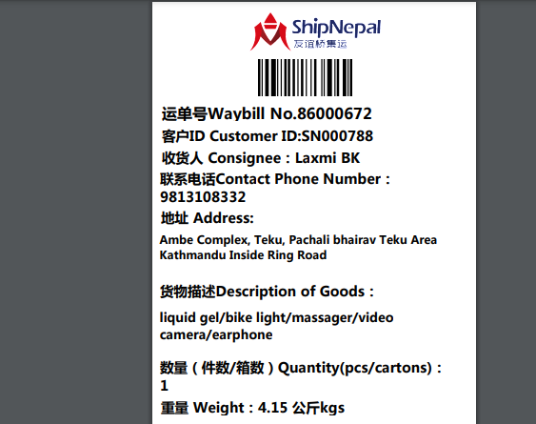

Deliver the rest items in Case No. 673-4 together with other 3 packages to the following after issuing another customs bill, collecting customs fees
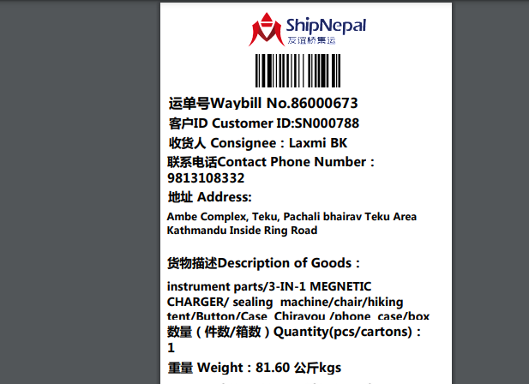
(Reminder: deliver to the same customer with two customs bills, delive total 5 packages)

