DELIVERY ARRANGEMENT (9)
Dated: August 18 , 2024
- Shipping mark: POAT, 1 package, case No. 631
Estimated arrival date in Kathmandu: August 12
Deliver to the following, collecting nothing
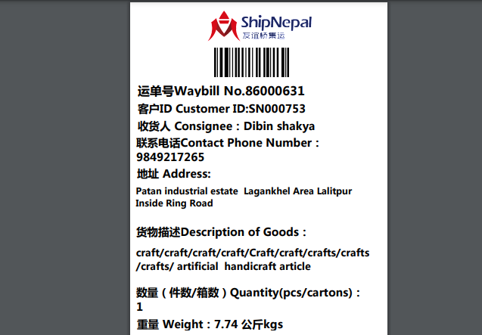

- Shipping mark: MUDP, 1 package, case No. 652
Estimated arrival date in Kathmandu: August 20
Deliver to the following, collecting nothing
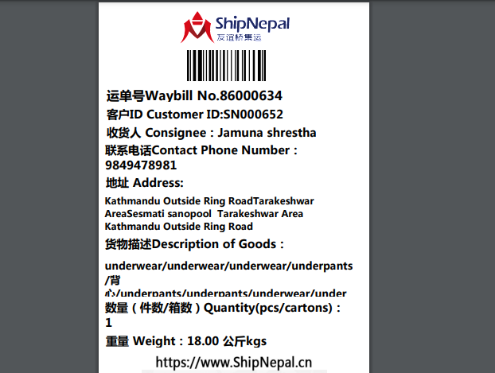

- Shipping mark: POAT, 2 packages, case No. 635-1, 635-2
Estimated arrival date in Kathmandu: August 17
Open the case No. 635-2. Shown as below
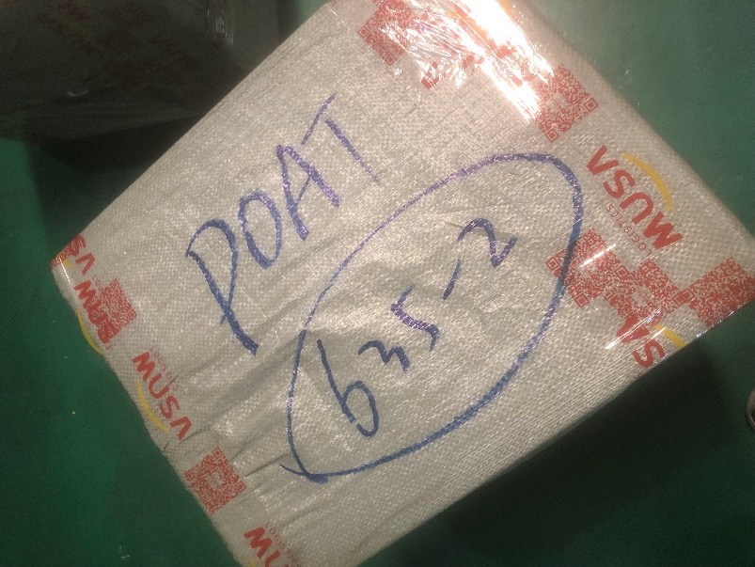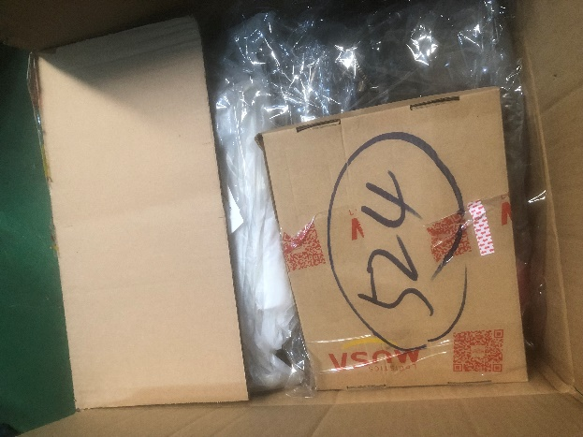
Taking out the box 524, deliver to SN000524 for free
Deliver the rest to the following, collecting nothing
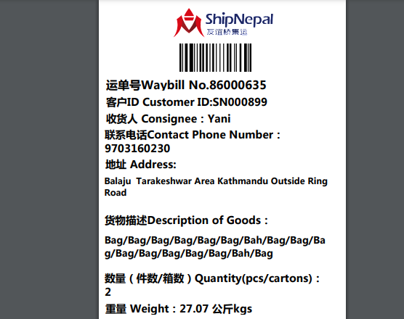

- Shipping mark: SNAT, 1 package, case No. 637
Estimated arrival date in Kathmandu: August 18
Delivery address as below, collecting nothing
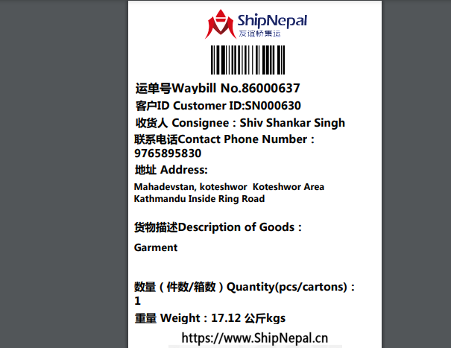
- Shipping mark: SNAT, 1 package, case No. 638
Estimated arrival date in Kathmandu: August 19
Deliver to the following, collecting nothing
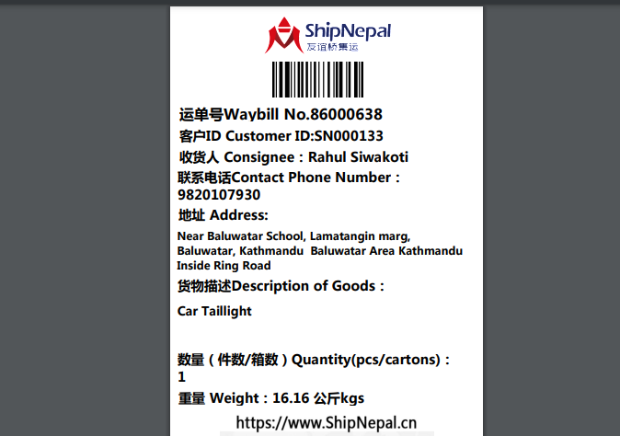

- Shipping mark: SNAT, 1 package, case No. 639
Estimated arrival date in Kathmandu: August 19
Deliver to the following, collecting nothing
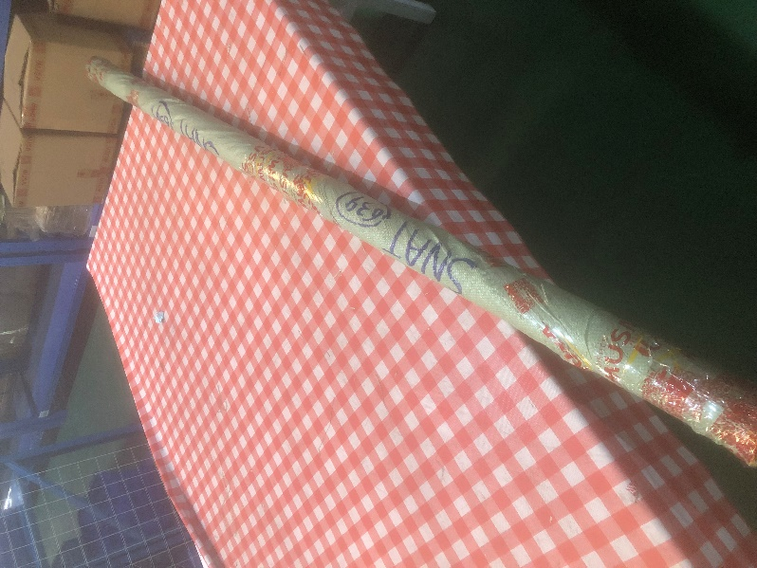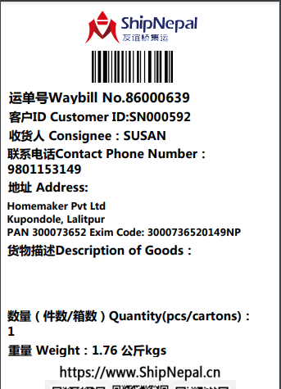

- Shipping mark: MUDP, 2 packages, case No. 640-1,640-2
Estimated arrival date in Kathmandu: August 29
Deliver to the following, collecting nothing
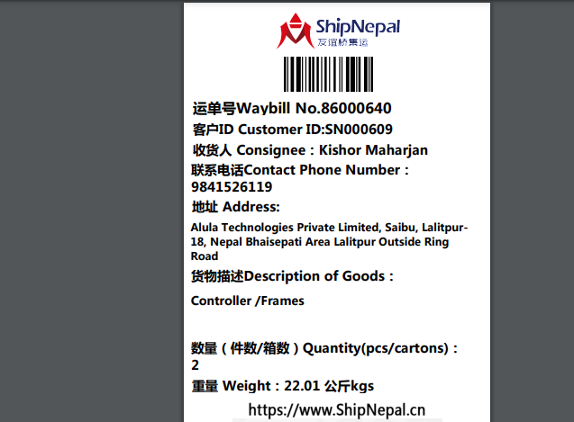
- Shipping mark: UMDP, 3 packages, case No. 643-1-2-3
Estimated arrival date in Kathmandu: August 31
Deliver to the following, collecting customs fees
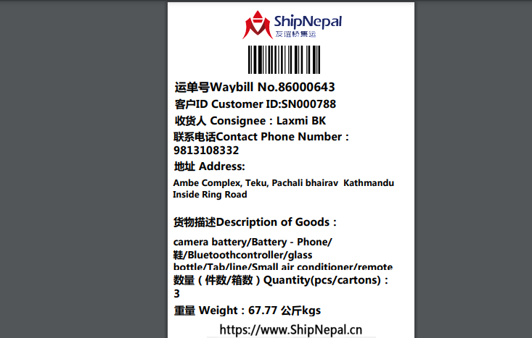

9. Shipping mark: MUDP, 1 package, case No. 646
Estimated arrival date in Kathmandu: August 31
Delivery address as below, collecting nothing
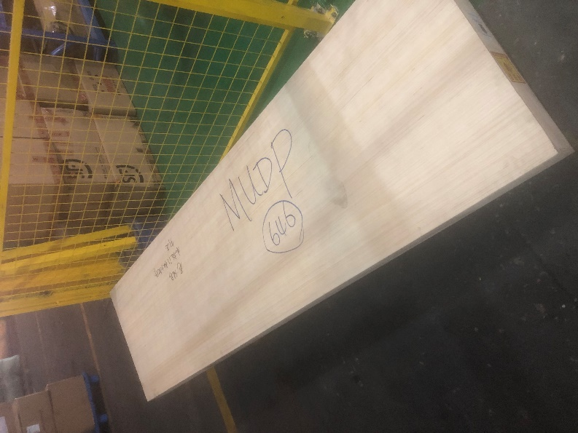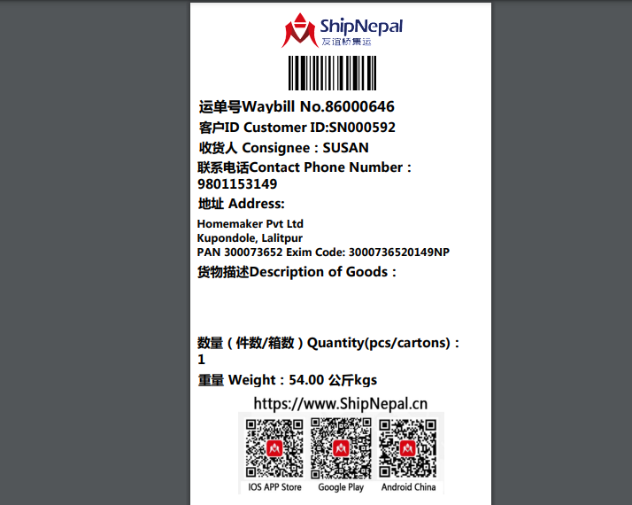

10. Shipping mark: SNAT, 1 package, case No. 648
Estimated arrival date in Kathmandu: August 29
Deliver the rest to the following , collecting nothing
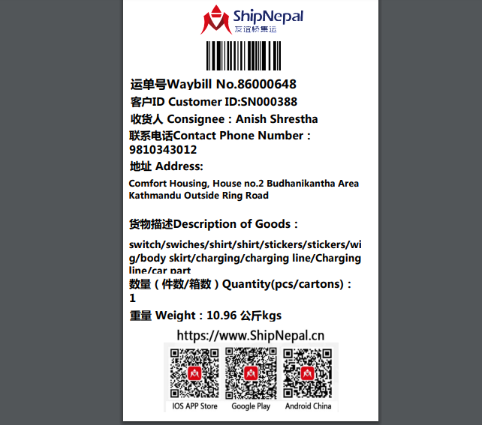
11. Shipping mark: SNAT, 1 package, case No. 654
Estimated arrival date in Kathmandu: August 29
Deliver to the following , collecting nothing
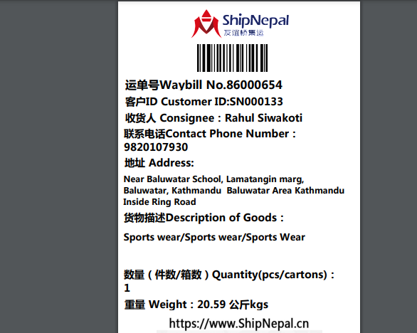
12. Shipping mark: UPAT, 4 packages, case No. 649-1-2-3-4
Estimated arrival date in Kathmandu: August 31
Deliver to the following, collecting customs fees
