DELIVERY ARRANGEMENT (8)
Dated: August 1 , 2024
- Shipping mark: UPAT, 6 packages, case No. 608-1-2-3-4-5-6
Estimated arrival date in Kathmandu: July 30
Deliver to the following, collecting customs fees
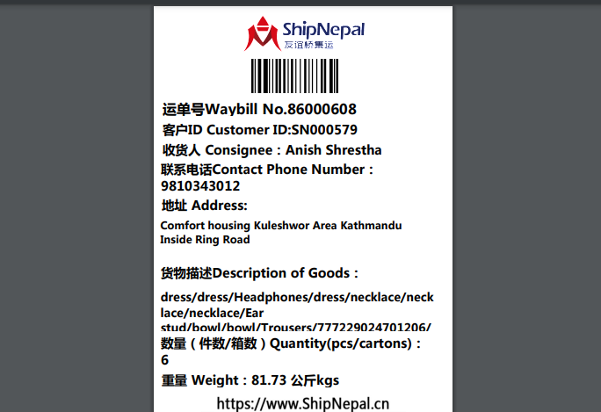

- Shipping mark: UMDP, 14 packages, case No. 611-1-14
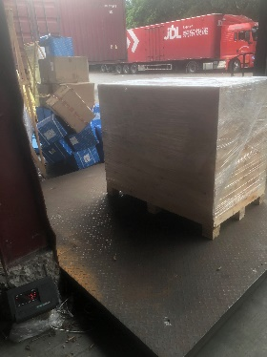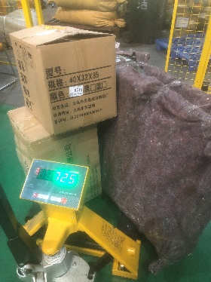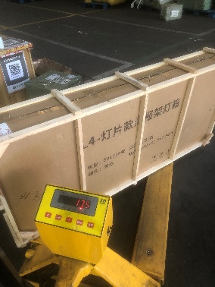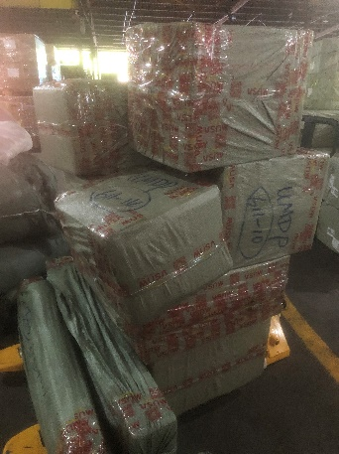
Estimated arrival date in Kathmandu: August 8
Total about 450kgs, the biggest package case No. 611-1 is a machine, 155kg
Ready to transship to Porkhara, collecting customs fees
Issuing customs builty, ask Hans to collecting fees, and estimate the freight from Kathmandu to Porkara. Once get ordered, transship to Porkhra.
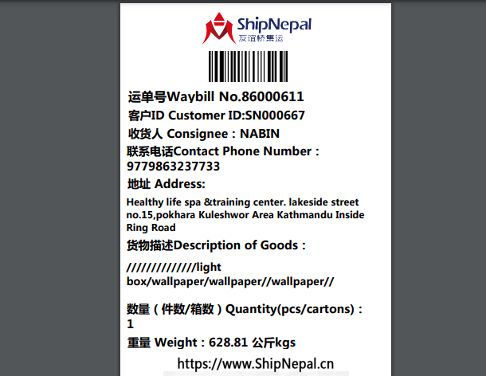

- Shipping mark: SGDP, 4 packages, case No. 614-1-2-3-4 Estimated arrival date in Kathmandu: August 10
Delivery address to be decided, collecting nothing

- Shipping mark: MUDP, 1 package, case No. 615
Estimated arrival date in Kathmandu: August 10
Delivery address to be decided, collecting nothing

- Shipping mark: UMDP, 7 packages, case No. 622-1-2-3-4-5-6-7
Estimated arrival date in Kathmandu: August 13
Deliver case No. 622-1-2-3-4-5-6 to the following, collecting customs fees
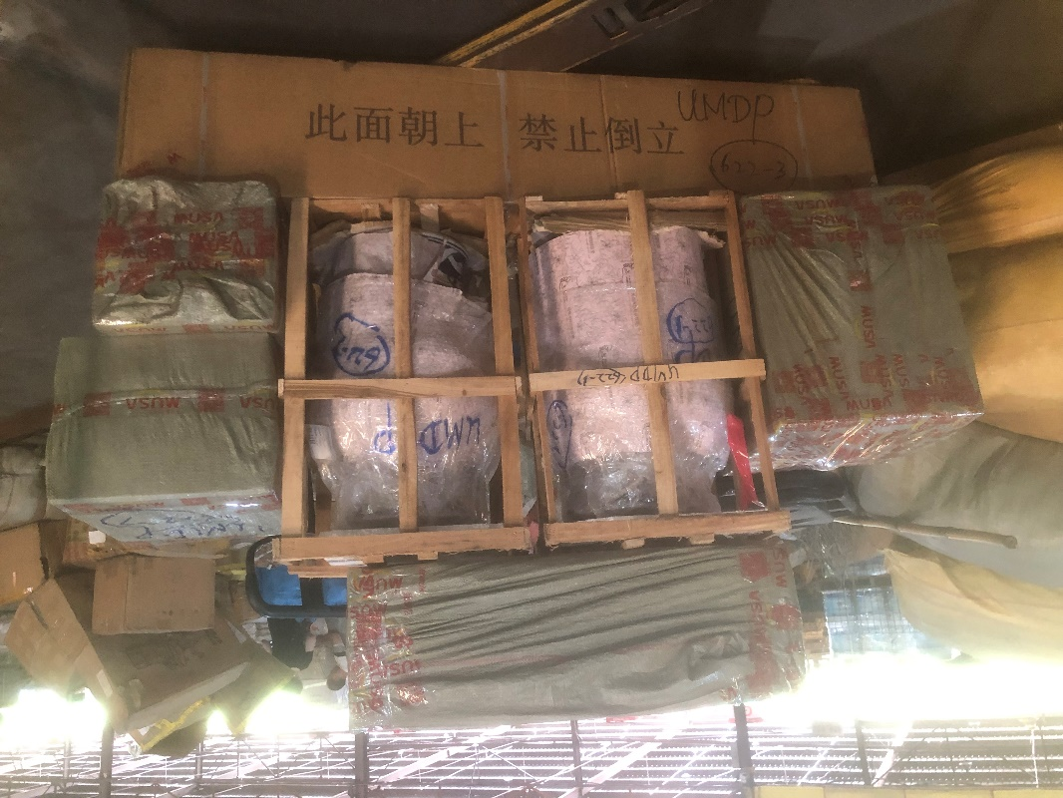
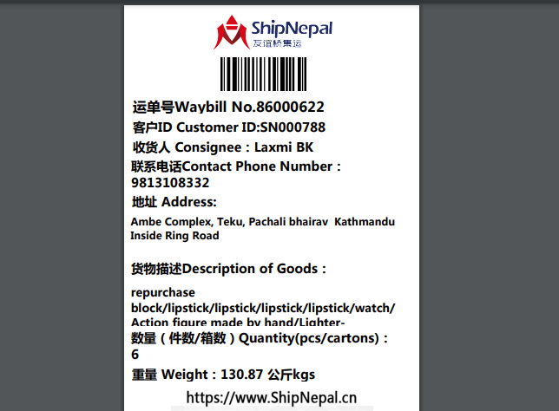
Deliver Case No. 622-7 to the following, collecting nothing
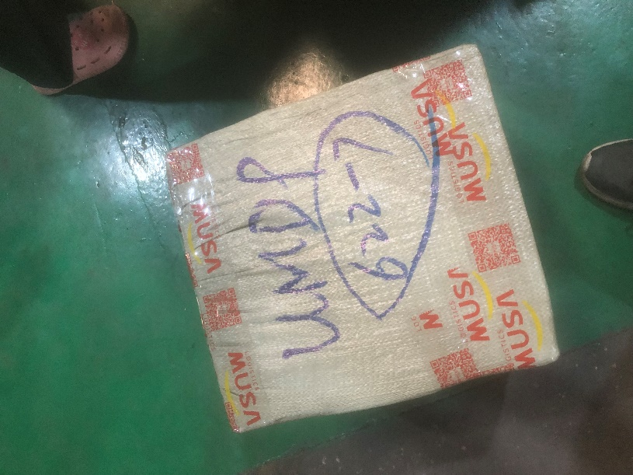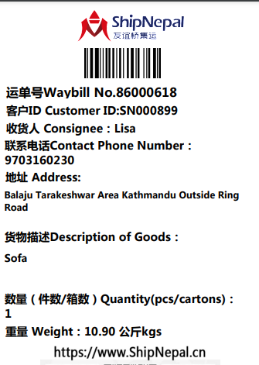

- Shipping mark: UPAT, 2 packages, case No. 623-1-2
Estimated arrival date in Kathmandu: August 8
Open the case No. 623-2, shown as below
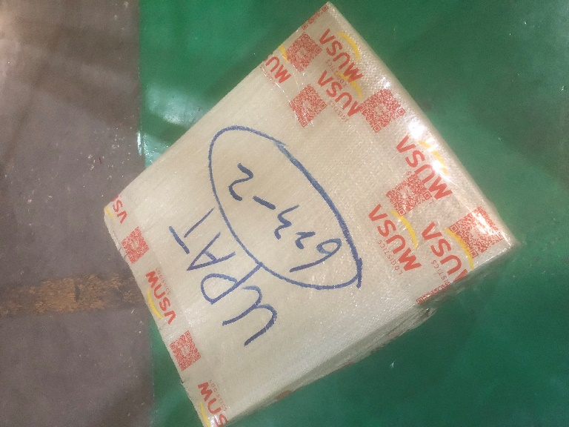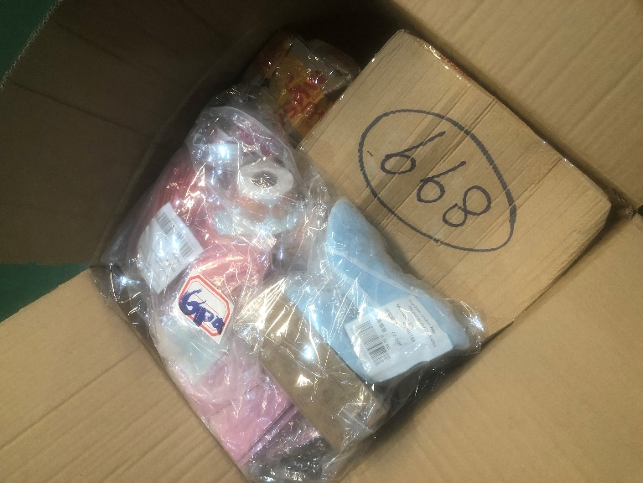
Taking out the box 899, deliver to the following, collecting nothing
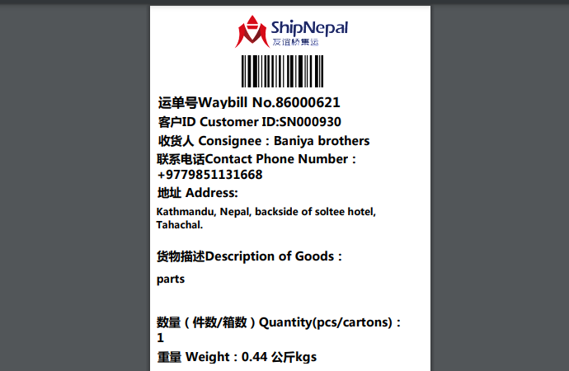

Deliver the rest to the following, collecting customs fees
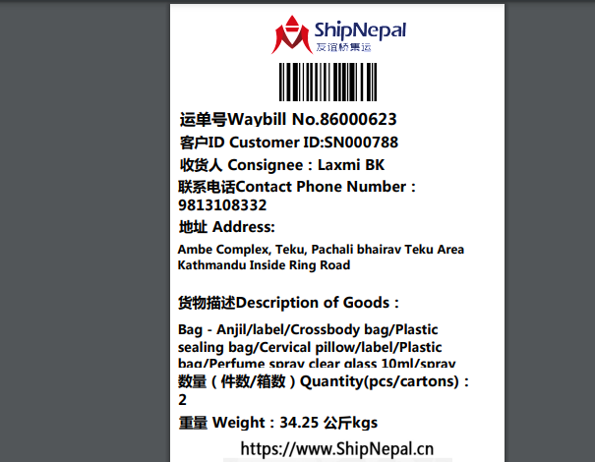

- Shipping mark: SGDP, 2 packages, case No. 627, 628
Estimated arrival date in Kathmandu: August 20
Deliver to the following, collecting nothing
