DELIVERY ARRANGEMENT (7)
Dated: July 15 , 2024
- Shipping mark: UPAT, 5 packages, case No. 593-1-2-3-4-5
Estimated arrival date in Kathmandu: July 15
Open the package Case No. 593-3 shown as below:
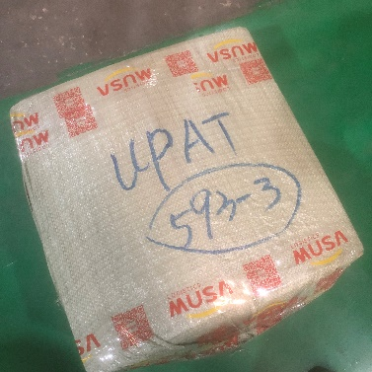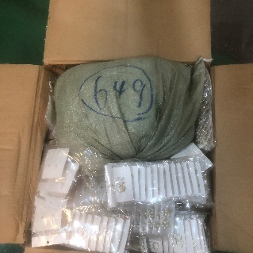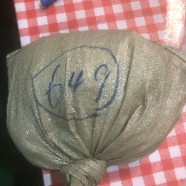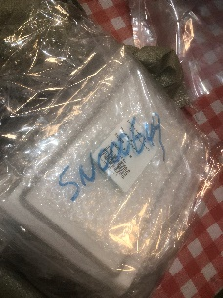
Taking out the bag 649, deliver to the following collecting nothing
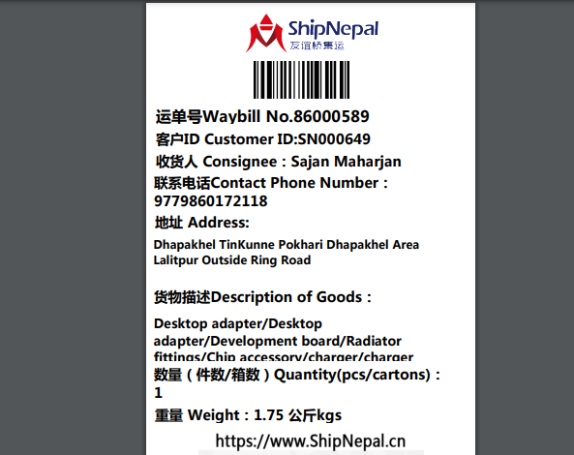

Deliver the rest in his package together with other cases No. 593-1-2-4-5 to the following, collecting customs fees
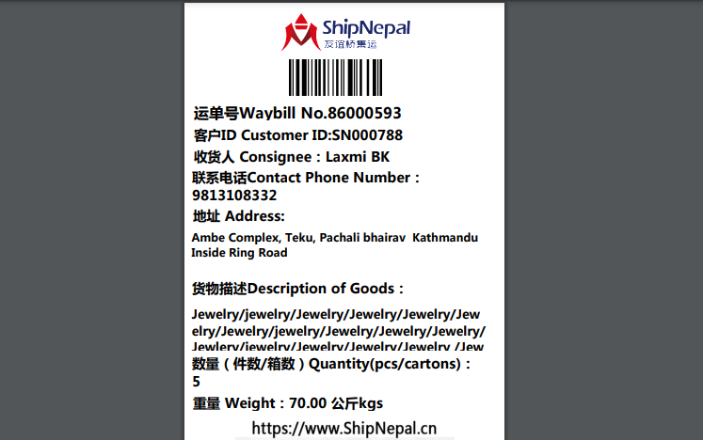

- Shipping mark: MUDP, 8 packages, case No. 592-1-2-3-4-5-6-7-8
Estimated arrival date in Kathmandu: July 25
Deliver to the following, collecting nothing
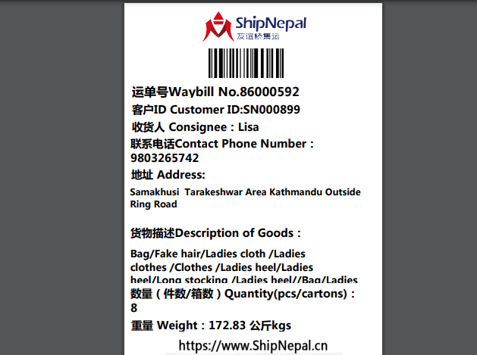

- Shipping mark: UMDP, 7 packages, case No. 595-1-2-3-4-5-6-7
Estimated arrival date in Kathmandu: July 20
Open case No. 595-7, shown as below:
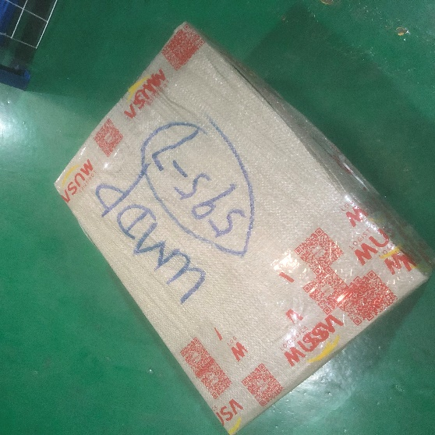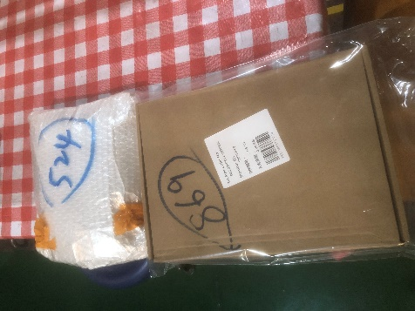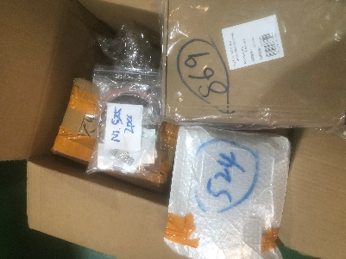
Taking out box 869, deliver to the following, collecting nothing
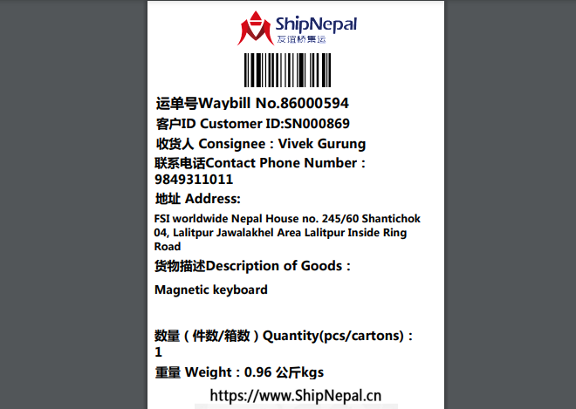
Taking out bags marked 524 and 525, deliver to whoever you like (as Candy says), collecting nothing;

Deliver the rest items in this package together with other 6 packages to the following, collecting customs fees
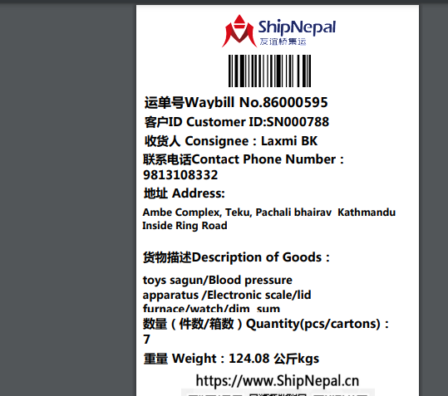

- Shipping mark: SNAT, 1 package, case No. 596598
Estimated arrival date in Kathmandu: July 18
Open the package, shown as below
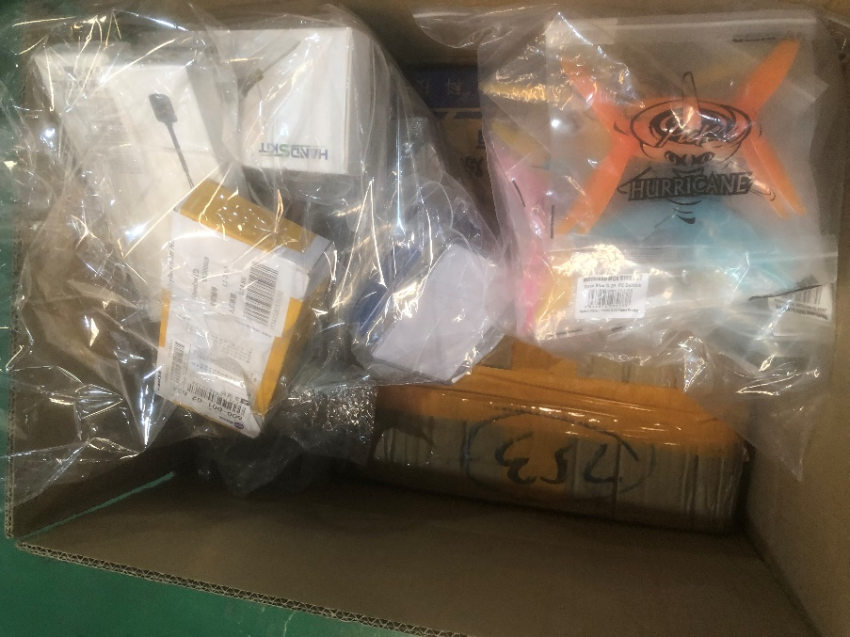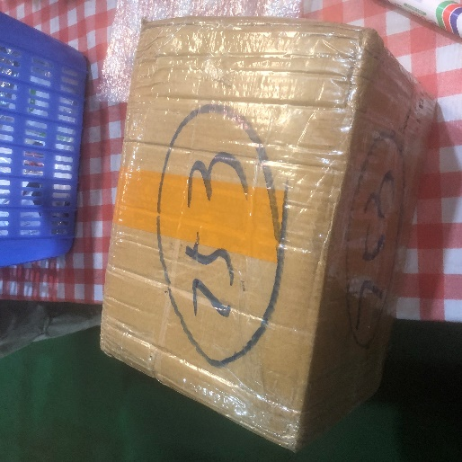
Taking out box 753 deliver to the following, collecting nothing
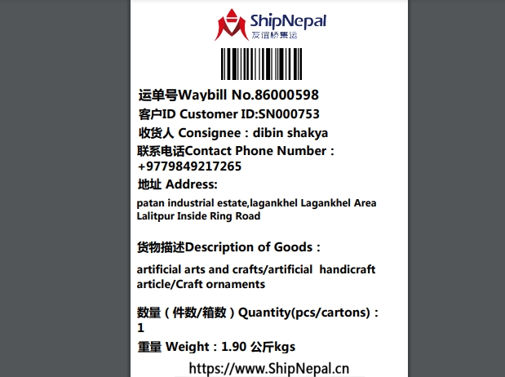

Deliver the rest to the following, collecting nothing
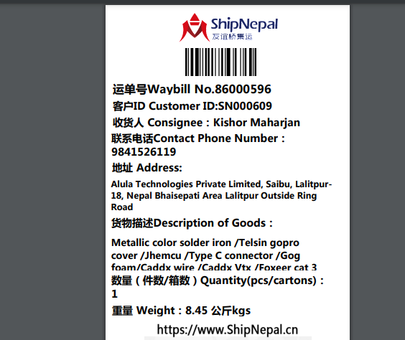
- Shipping mark: SGDP, 1 package, case No. 600
Estimated arrival date in Kathmandu: July 25
Deliver to the following, collecting nothing
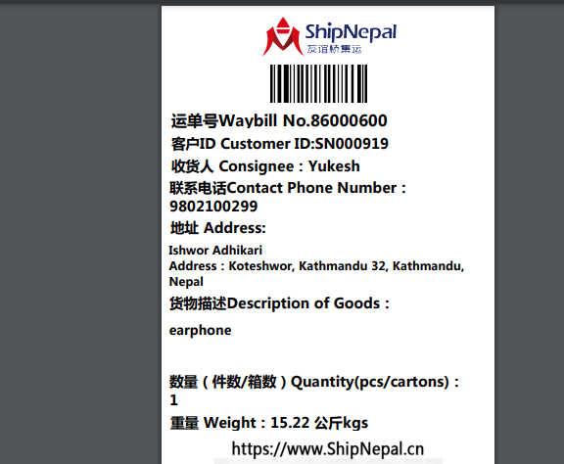

- Shipping mark: SGDP, 2 packages, case No. 597-1-2
Estimated arrival date in Kathmandu: July 25
Deliver to the following, collecting nothing
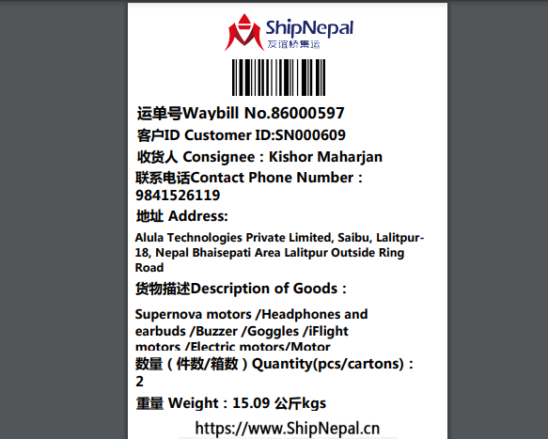
- Shipping mark: MUDP, 2 packages, case No. 601604-1-2
Estimated arrival date in Kathmandu: July 30
Open the package case No. 601604-2, show as below:
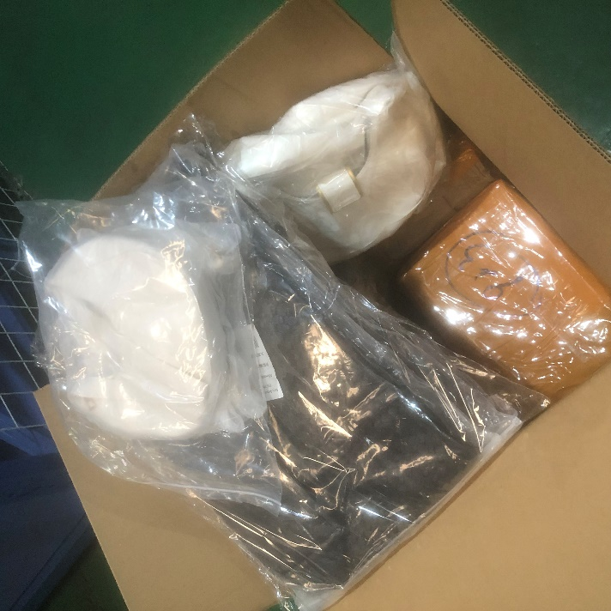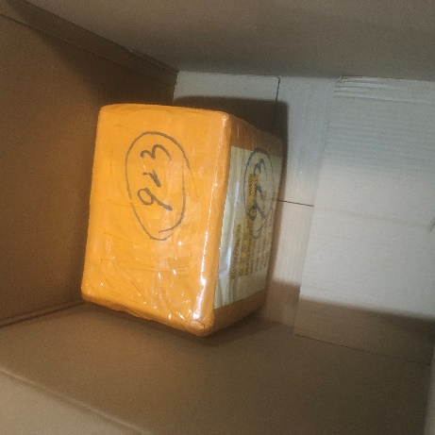
Taking out the box 923, together with package case No. 601604-1, deliver to the following, collecting nothing
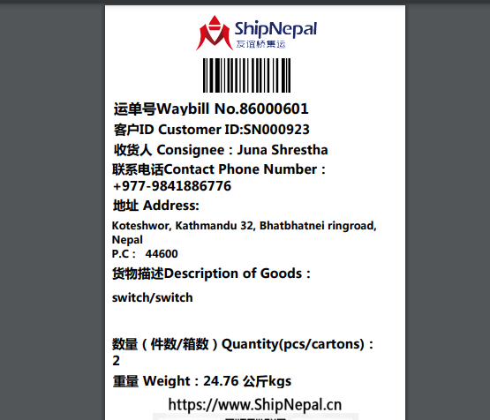

After taking out box 923, deliver all the rest in package 601604-2 to the following, collecting nothing
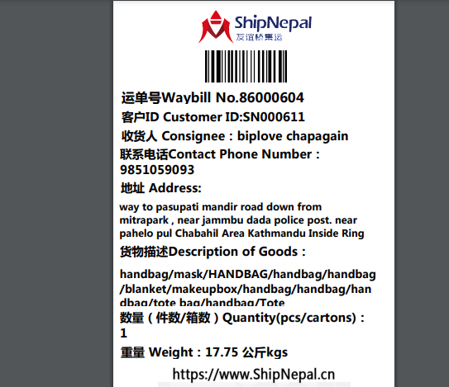

- Shipping mark: SNAT, 1 package, case No. 605606
Estimated arrival date in Kathmandu: July 25
Open the package, show as below:
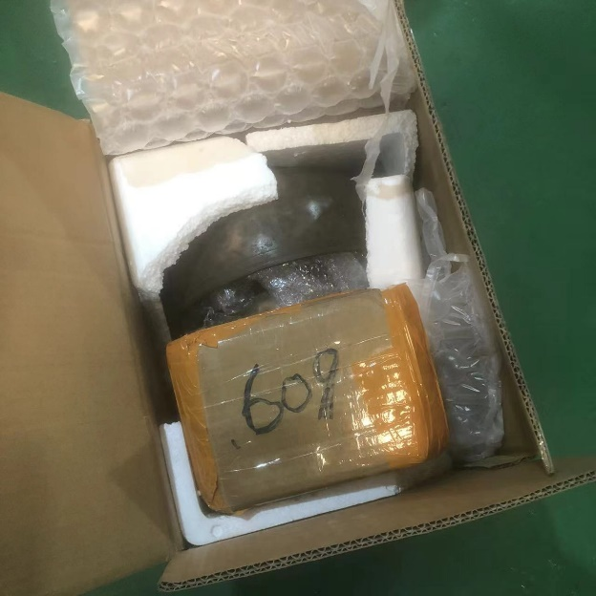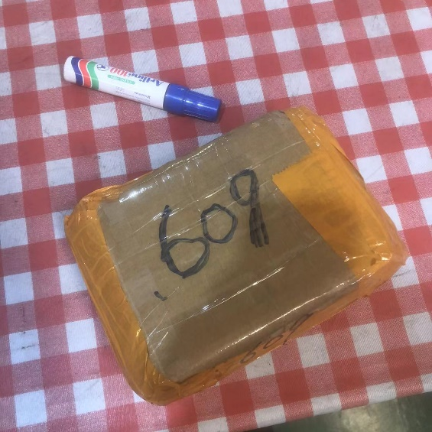
Taking out box 609, deliver to the following, collecting nothing
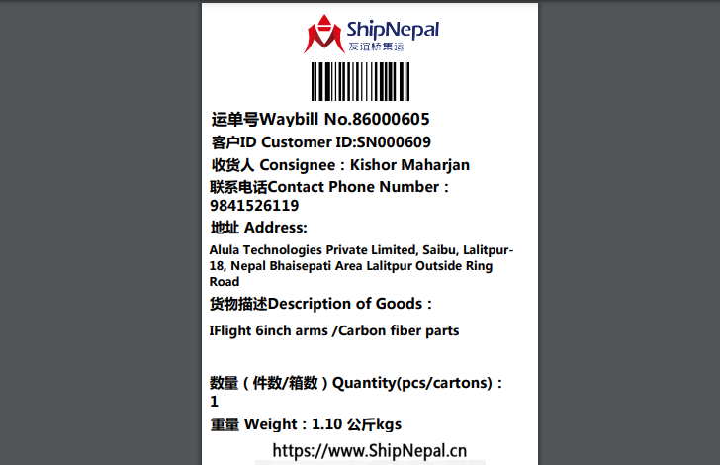

Deliver the rest (5 bowls) to the following, collecting nothing
