DELIVERY ARRANGEMENT (6)
Dated: July 1, 2024
- Shipping mark: MUDP, 1 package, case No. 575
Estimated arrival date in Kathmandu: June 28
Open the package, shown as below:
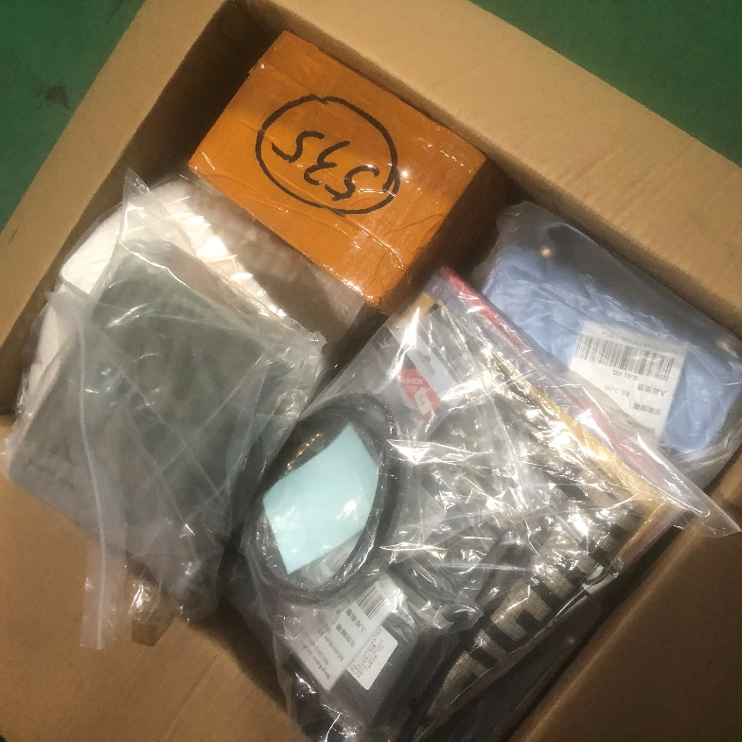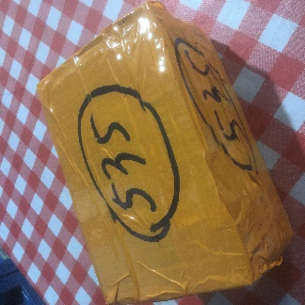
Taking out the box 535, deliver to HOU ZHIHONG for free

Deliver the rest to the following, collecting nothing
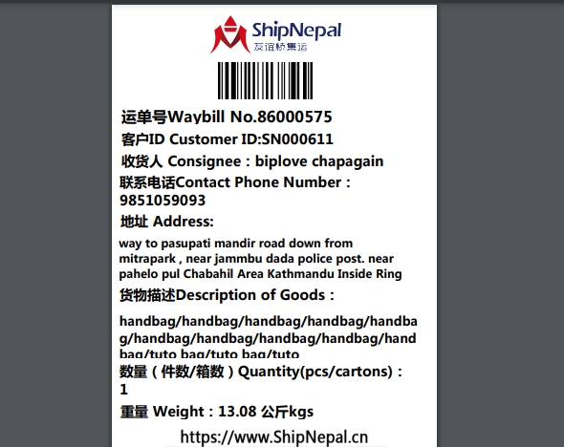
- Shipping mark: UPAT, 2 packageS, case No. 576-1,576-2
Estimated arrival date in Kathmandu: June 30
Deliver to the following, collecting customs fees
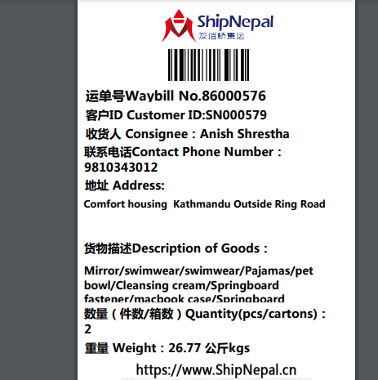

- Shipping mark: UMDP, 3 packages, case No. 577-1,577-2,577-3
Estimated arrival date in Kathmandu: July 10
Deliver to the following, collecting customs fees
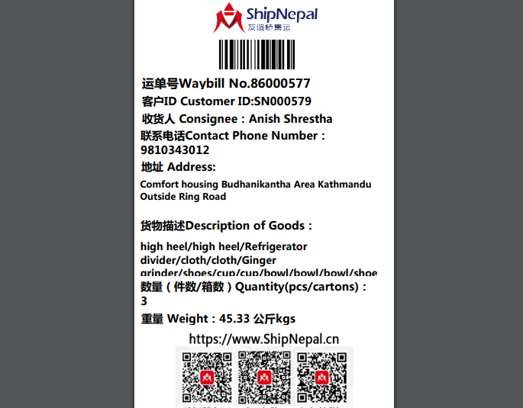
- Shipping mark: SGDP, 3 packages, case No. 579-1,579-2,579-3
Estimated arrival date in Kathmandu: July 10
Deliver to the following, collecting nothing
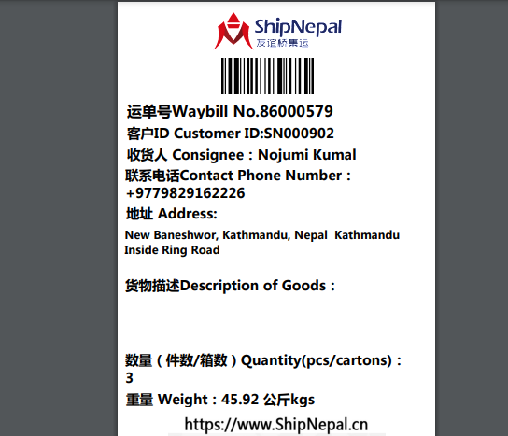

- Shipping mark: SGDP, 1 package, case No. 580
Estimated arrival date in Kathmandu: July 10
Deliver to the following, collecting nothing
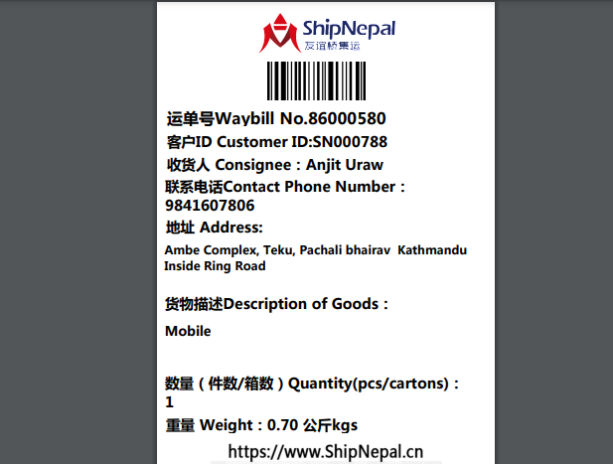
- Shipping mark: UPAT, 1 package, case No. 581
Estimated arrival date in Kathmandu: July 4
Deliver to the following, collecting customs fees
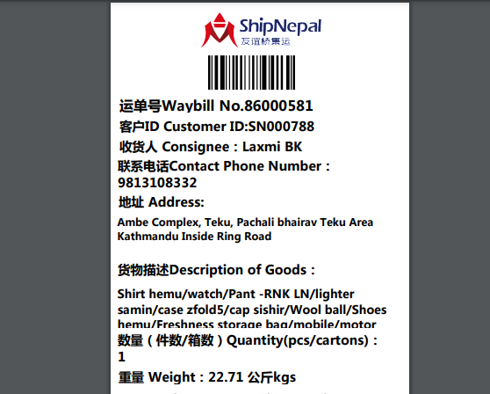

- Shipping mark: UMDP, 7 packages, case No. 582-1,582-2,582-3,582-4,582-5,582-6,582-7
Estimated arrival date in Kathmandu: July 17
Deliver to the following, collecting customs fees
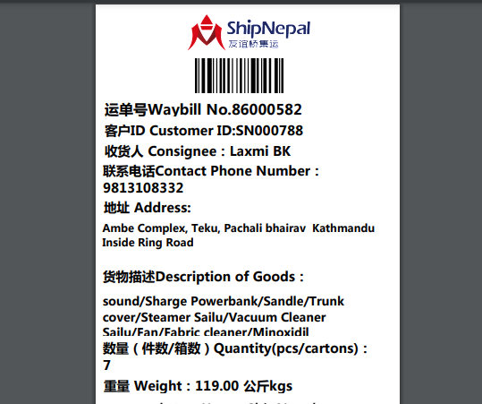

- Shipping mark: MUDP, 1 package, case No. 584
Estimated arrival date in Kathmandu: July 12
Deliver to the following, collecting nothing
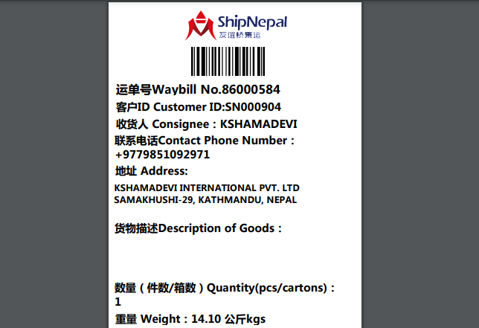

- Shipping mark: SNAT, 1 package, case No. 585
Estimated arrival date in Kathmandu: July 15
Deliver to the following, collecting nothing
