DELIVERY ARRANGEMENT (5)
Dated: June 7 , 2024

- Shipping mark: SNAT, 1 package, case No. 550
Estimated arrival date in Kathmandu: June 6
Deliver to the following address, collecting NOTHING
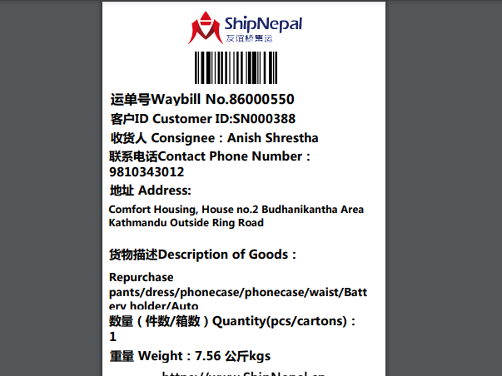

- Shipping mark: POAT, 4 packages, case No. 551-1,551-2,551-3 and 551-4
Estimated arrival date in Kathmandu: June 6
Delivering to the following, collecting cutoms fees
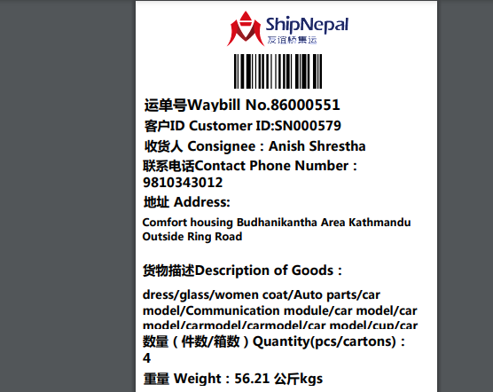

- Shipping mark: SNAT, 2 packages, Case No. 555-1, 555-2
Estimated arrival date in Kathmandu: June 8
Delivering to the following, collecting nothing
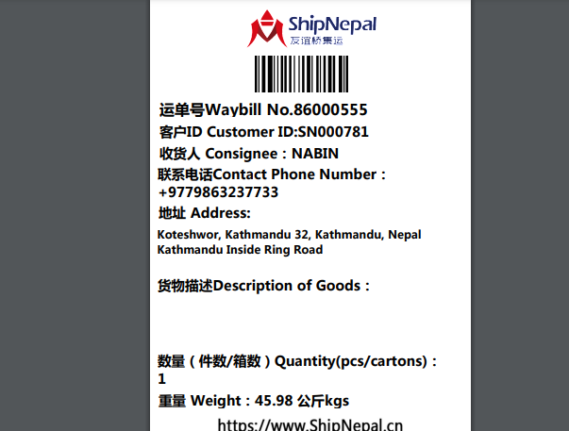waiting for notification

- Shipping mark: SGDP, 1 package, case No. 549554556
Estimated arrival date in Kathmandu: June 12
Open the package, shown as below:
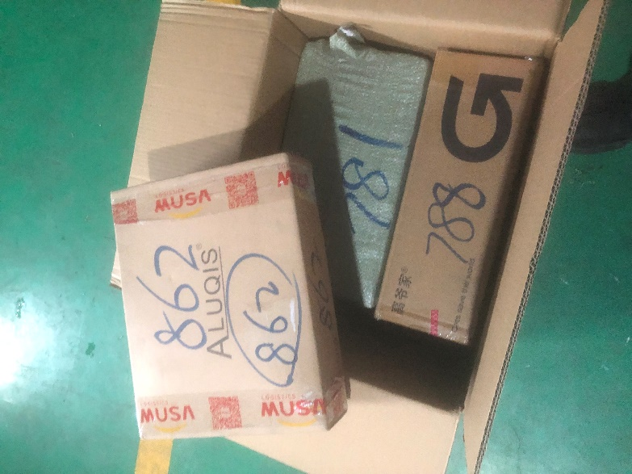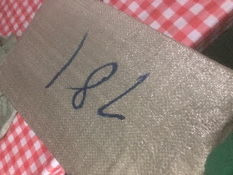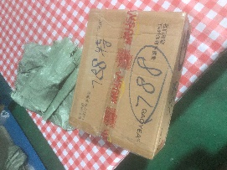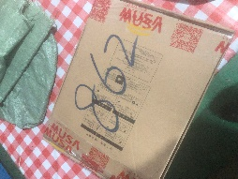

Taking out the box 862, deliver to the following, collecting nothing
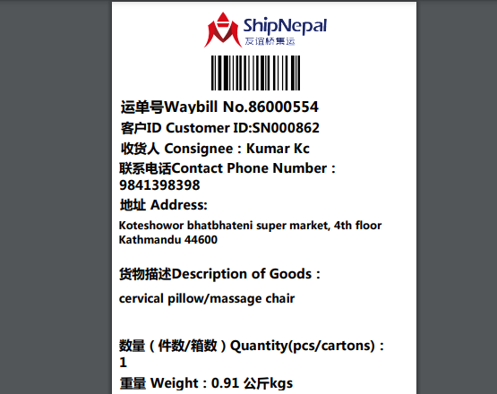

Taking out the box 788, deliver to the following, collecting nothing
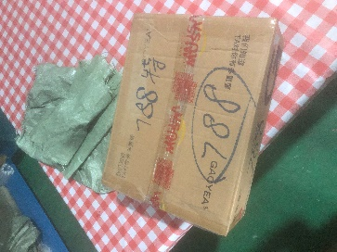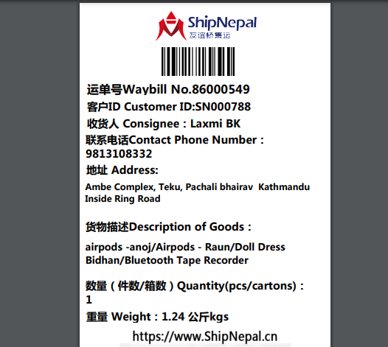

Taking out the box 781, deliver to the following, collecting nothing
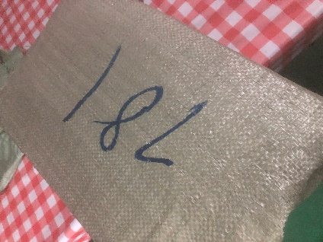 waiting for notification from Musa Guangzhou

- Shipping mark: SNAT, 1 package, case No. 558561
Estimated arrival date in Kathmandu: June 13
Open the package, shown as below:
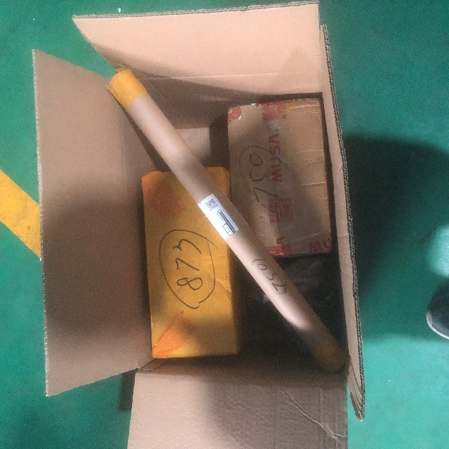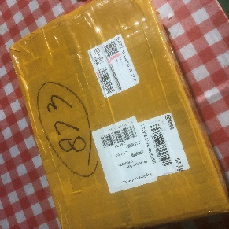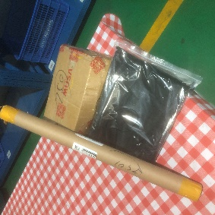
Taking out 873, deliver to the following add charging nothing
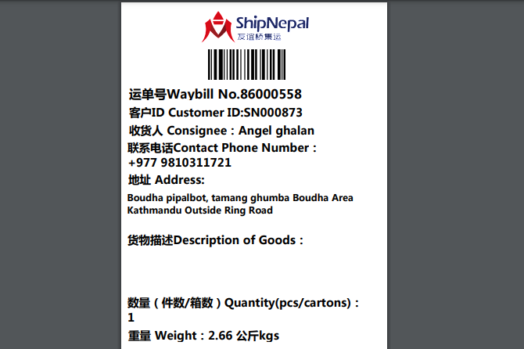

Deliver all the rest (marked 750) to the following charging nothing
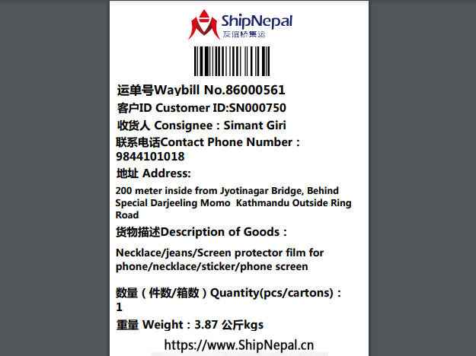

- Shipping mark: SGDP, 1 package, case No. 557
Estimated arrival date in Kathmandu: June 13
deliver to the following, collecting nothing
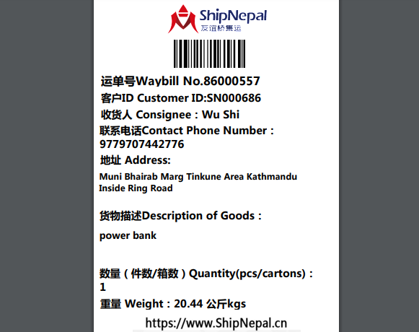

- Shipping mark: UPAT, 3 packages, case No. 562-1,562-2,562-3
Estimated arrival date in Kathmandu: June 16
Delivering to the following, collecting cutoms fees
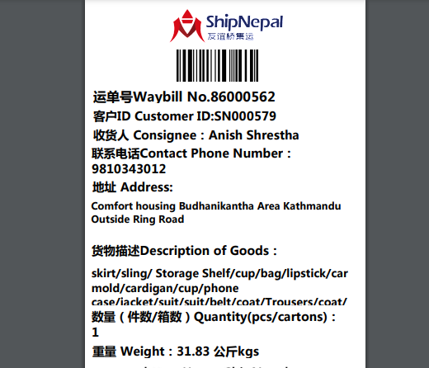

- Shipping mark: UPAT, 3 packages, Case No. 570-1,570-2,570-3
Estimated arrival date in Kathmandu: June 17
Delivering to the following, collecting cutoms fees
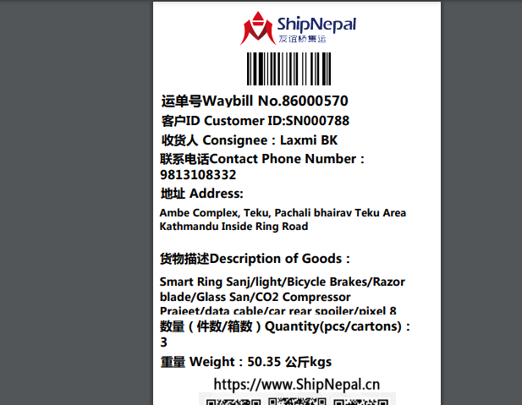

- Shipping mark: MUDP, 2 packages， case No. 567-1, 567-2
Estimated arrival date in Kathmandu: June 22
Delivering to the following, collecting nothing
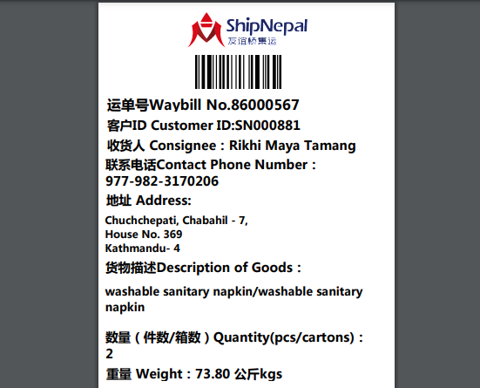

- Shipping mark: UGDP, 2 packages, Case No. 569-1, 569-2
Estimated arrival date in Kathmandu: June 22
Open the package case No. 569-1, shown as below
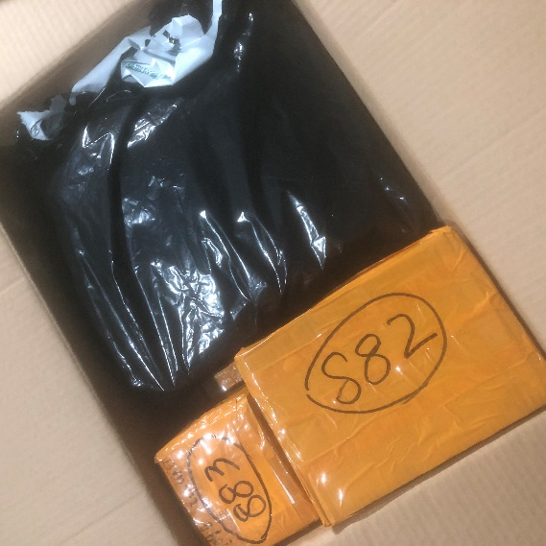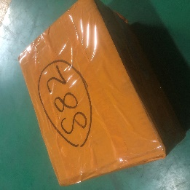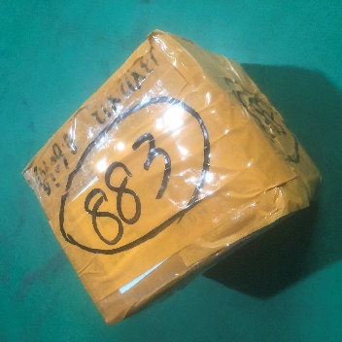

Taking out box 882, deliver to the following, collecting nothing
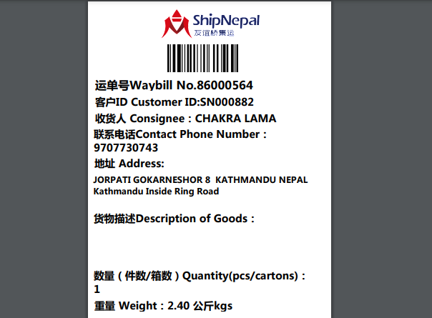

Taking out box 883, deliver to the following, collecting nothing
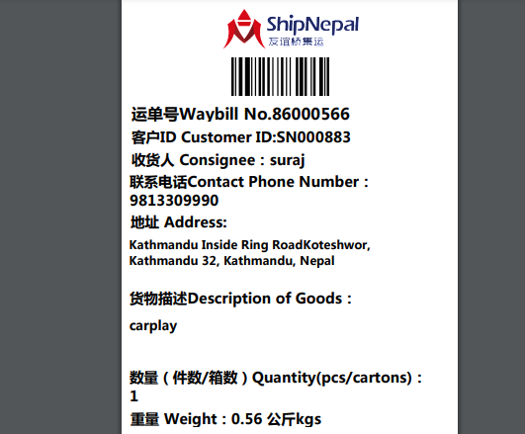

Deliver case No. 569-2 and the rest of items in 569-1 to the following, collecting cutoms fees
