DELIVERY ARRANGEMENT (4)
Dated: May , 2024

- Shipping mark: POAT, 1 package, case No. 543
Estimated arrival date in Kathmandu: June 2
Deliver to the following address, collecting customs fees
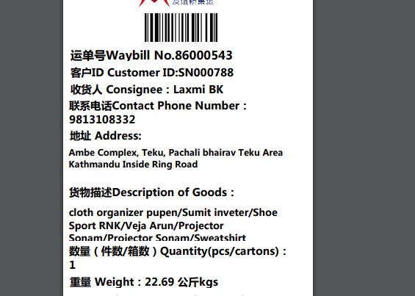

- Shipping mark: MUDP, 1 package, case No. 0511
Estimated arrival date in Kathmandu: MAY 30
Open the package, shown as below
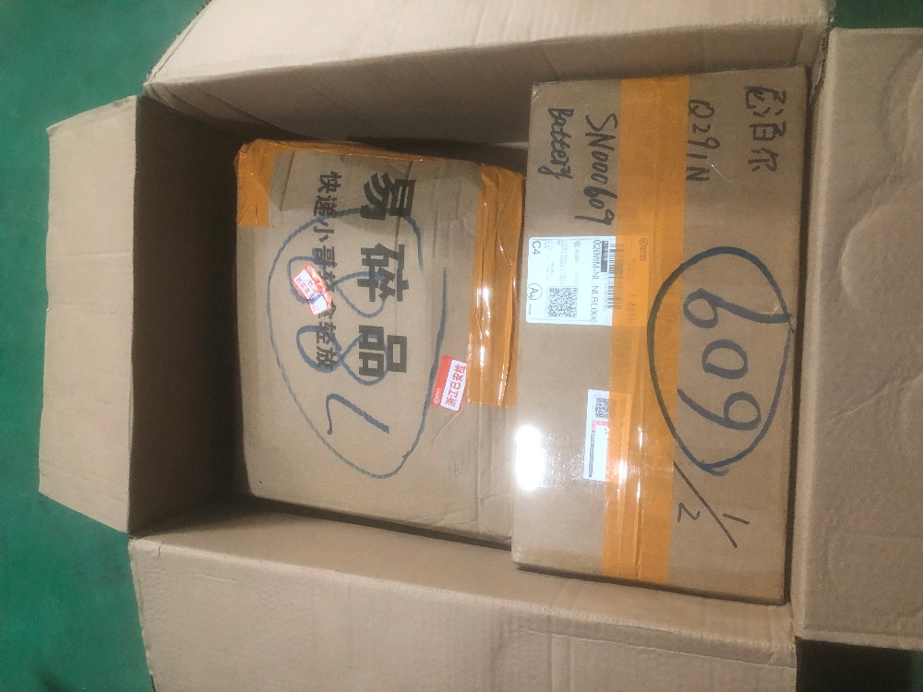
For box No. 788, delivering to the following, collecting nothing
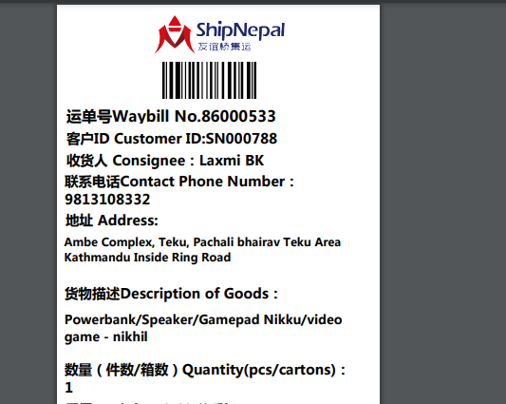

For box No. 609, delivering to the following, collecting nothing
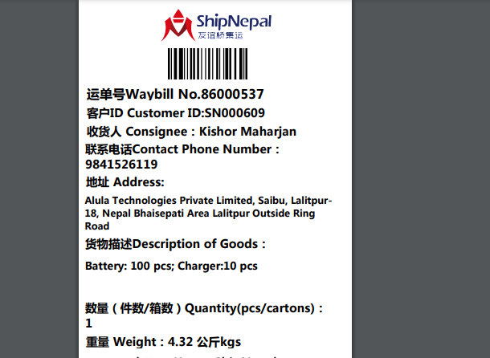

- Shipping mark: POAT, 2 packages, Case No. 548-1, 548-2
Estimated arrival date in Kathmandu: June 6
Deliver to the following address, collecting customs fees
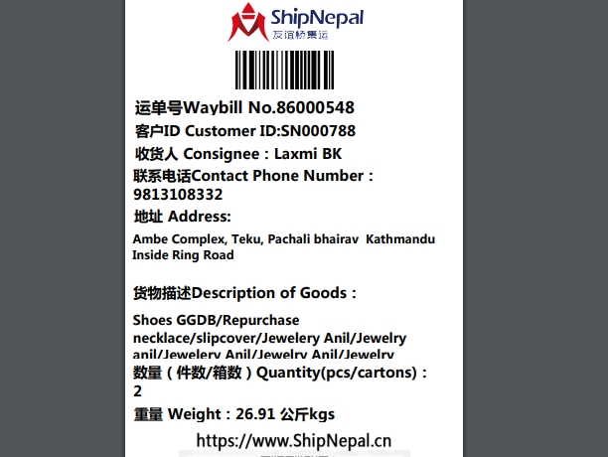
- Shipping mark: MUDP, 1 package, case No. 539544
Estimated arrival date in Kathmandu: June 10
Open the package, shown as below
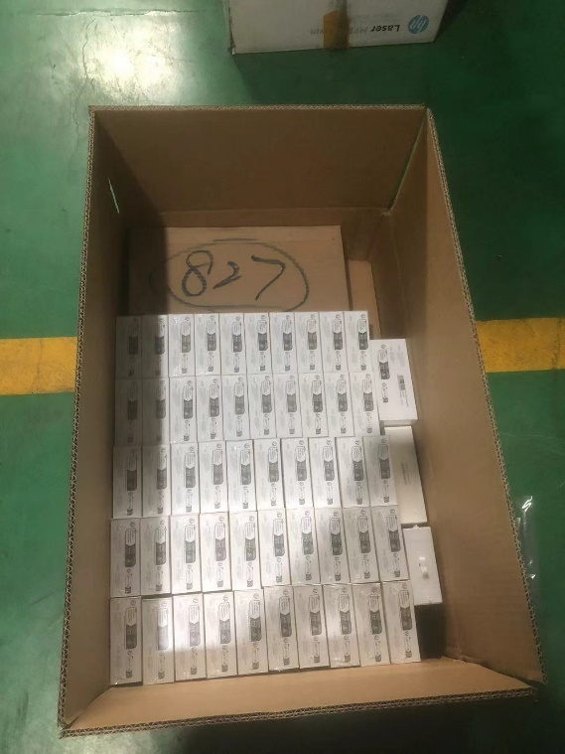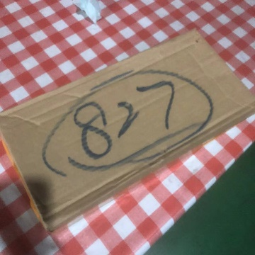
Take out the box marked 827, and deliver this box to the following, collecting and charging nothing:
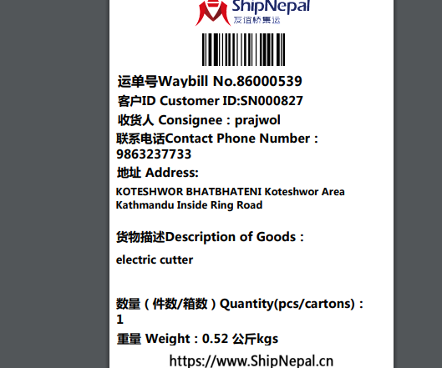

Deliver the rest (total 53pcs of small boxes) to the following, collecting and charging nothing:
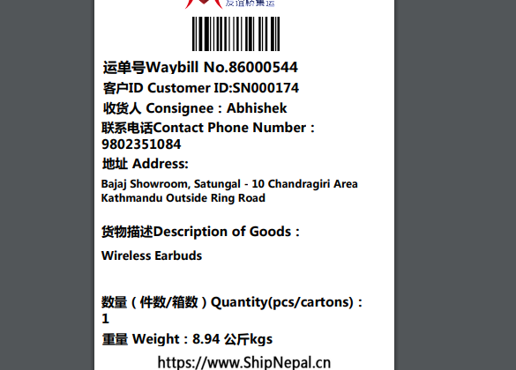

- Shipping mark: MUDP, 7 package, case No. 545-1，545-2，545-3，545-4，545-5， 545-6 and 545-7
Estimated arrival date in Kathmandu: June 10
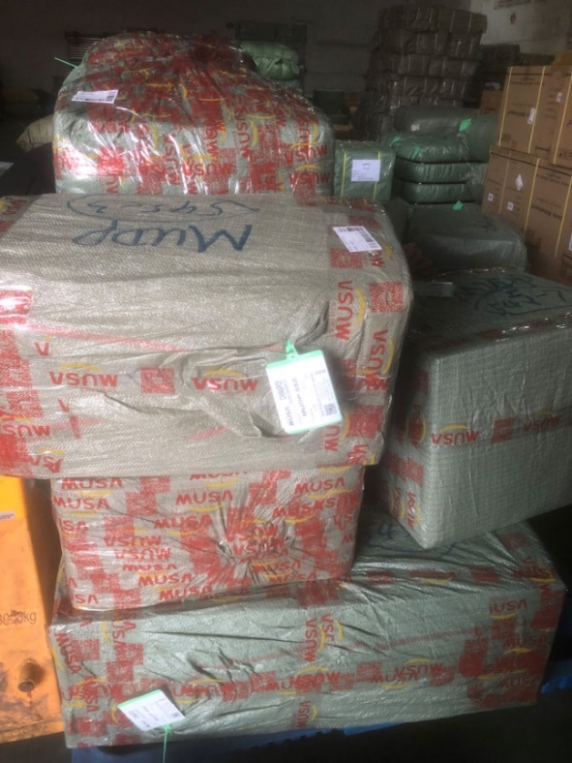 109kgs
Transshipped these 7 packages to Porkhra, address will be advised to you once received. You pay the local freight from Kathmandu to Porkhra and get the freight bilty sending to me (I’ll collect the freight according to your bilty)

