DELIVERY ARRANGEMENT (3)
Dated: May 7, 2024

- Shipping mark: MUDP, 2 package, case No. 788 and 609
Estimated arrival date in Kathmandu: MAY 17
For case No. 788, delivering to the following, collecting nothing
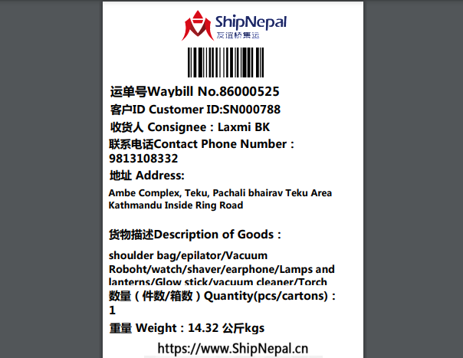

For case No. 609, delivering to the following, collecting nothing
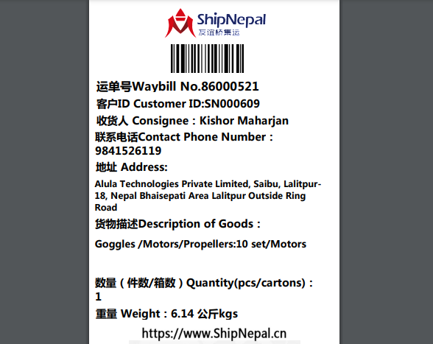
- Shipping Mark: POAT, 1 package, case No. 788
Estimated arrival date in Kathmandu: May 12
Deliver to the following address, collecting customs fees and delivery fees
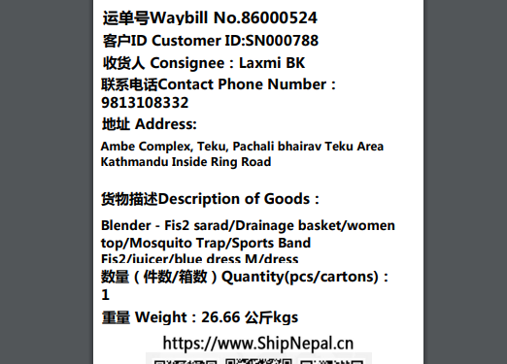

- Shipping Mark: POAT, 1 package, case No. 769
Estimated arrival date in Kathmandu: May 10
Delivery to the following address, collecting fees and delivery fees
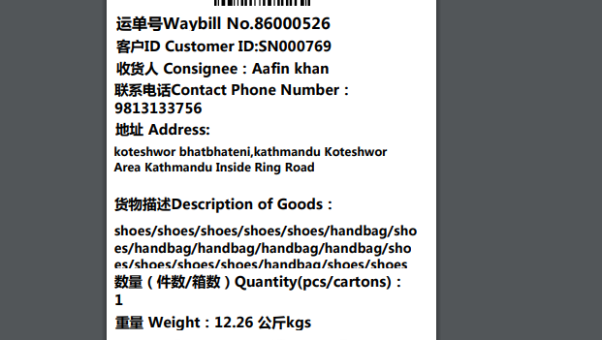
- Shipping Mark: POAT, 3 packages, case No. 579-1,579-2 and 579-3
Delivery to the following, collecting cusotms fees and delivery fees
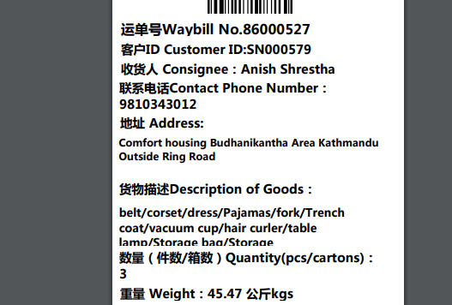

- Shipping Mark: SNAT, 1 package, case No. 388
Delivery to the following, collecting nothing
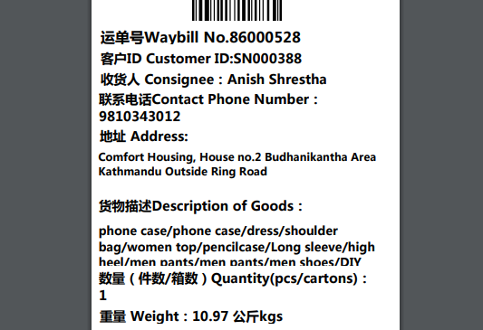

- Shipping Mark: MUDP, 2 large packages, case No. 846-1,846-2
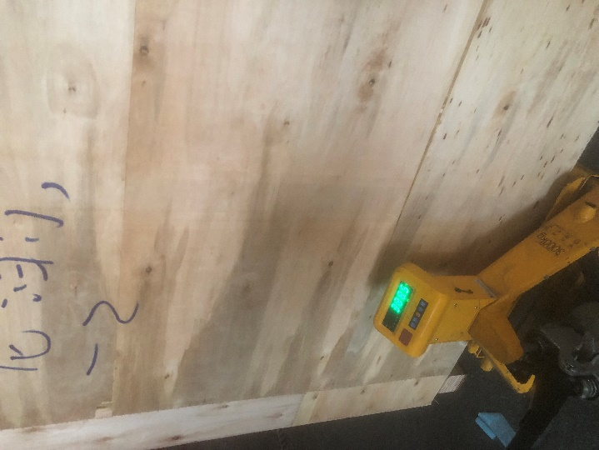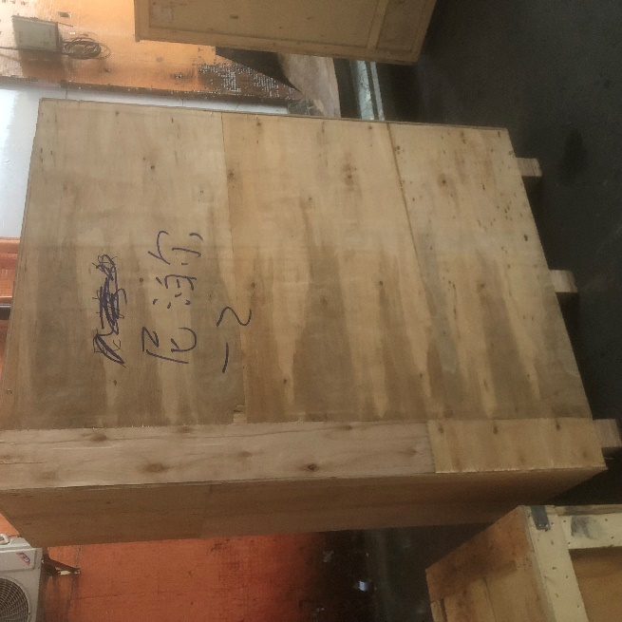
Each box about 400kg, once arrived, customer will pickup themselves at our warehouse. Collecting nothing

- Shipping Mark: POAT, 2 packages, case No. 788-1,788-2
Estimated arrival: May 18 ( departure date from Chian: May 7)
Delivery to the following, collecting cusotms fees and delivery fees
