DELIVERY ARRANGEMENT (2)
Dated: April 24, 2024

- Shipping mark: MUDP, 2 packages, case No. M1, M2
Delivery to the following:


- Shipping mark: MUDP, 1 package, case No. 411 1 package
Estimated arrival date in Kathmandu: April 29
Open this package, taking out the box 788 out,
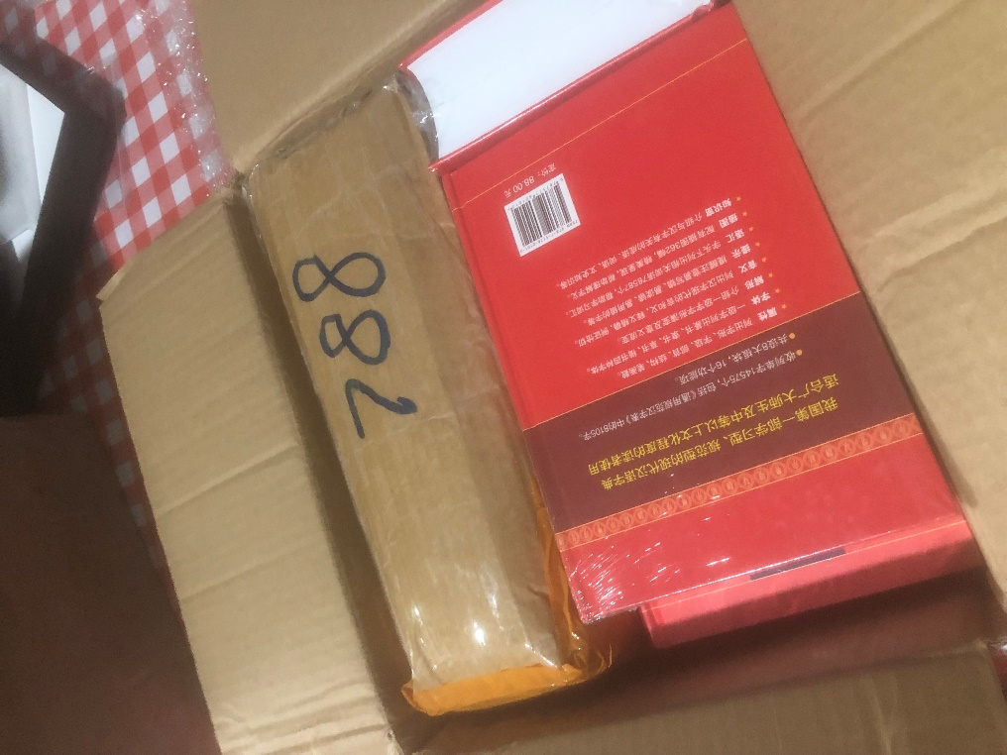
Deliver 788 it to the following customer collecting nothing else
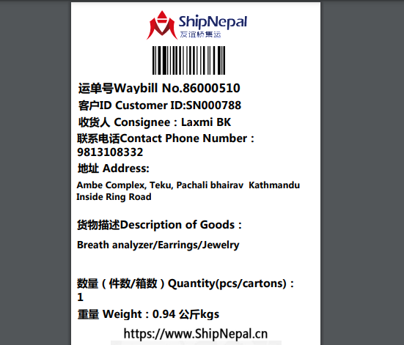

Deliver the rest (all books) to the following (collect nothing)
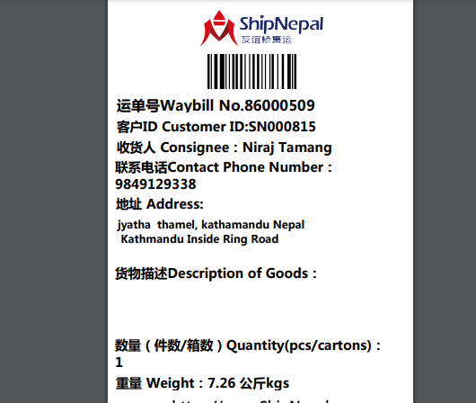

- Shipping Mark: MUDP, 1 package, case No. 815
Estimated arrival date in Kathmandu: May 5
Deliver to the following:
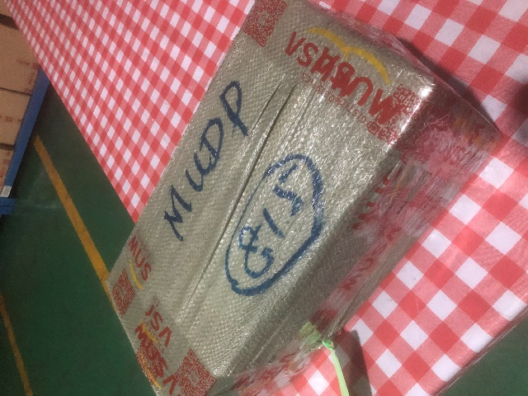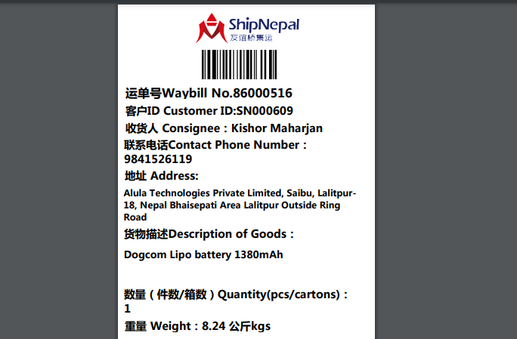

- Shipping Mark: POAT, 1 packages, case No. 788
Estimated arrival date in Kathmandu: May 2
Open this package, taking out the box 609 out,
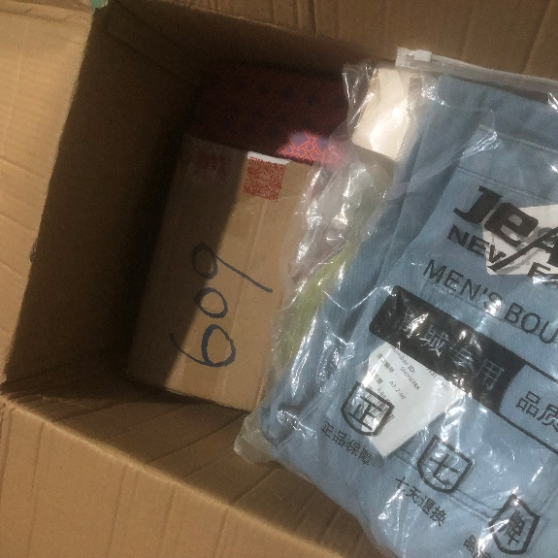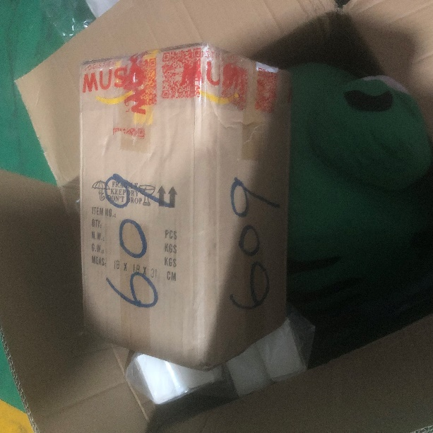
Deliver 609 to the following, collecting nothing

Deliver the rest to the following, and collect customs fees and delivery fees
