DELIVERY ARRANGEMENT (12)
Dated: Oct.24, 2024
- Shipping mark: MUDP, 6 package, case No. 697-1-2-3-4-5-6
Estimated arrival date in Kathmandu: Dec.10,2024
Deliver to the following, collecting nothing
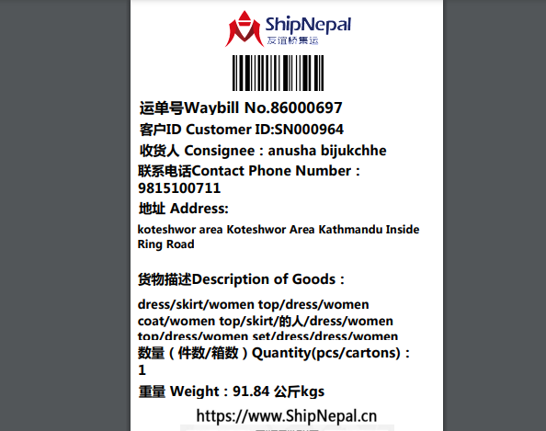

- Shipping mark: MUDP, 3 packages, case No. 699-1-2-3
Estimated arrival date in Kathmandu: Dec.10, 2024
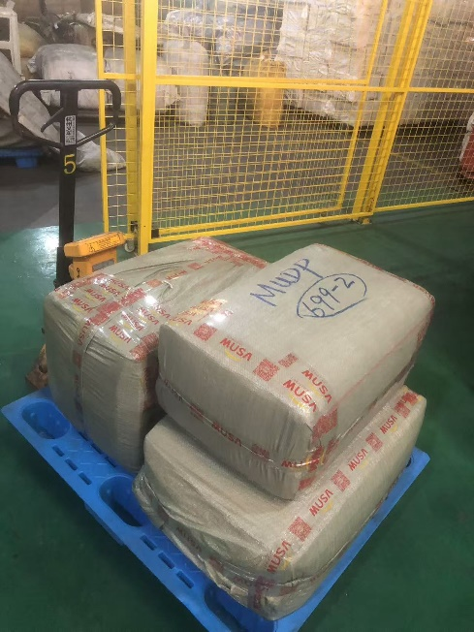
Deliver to the following, collecting nothing
