DELIVERY ARRANGEMENT (13)
Dated: Nov., 2024
- Shipping mark: UMDP, 6 packages, case No. 705-1-2-3-4-5-6
Estimated arrival date in Kathmandu: Dec. 3, 2024
Deliver to the following, collecting customs fees
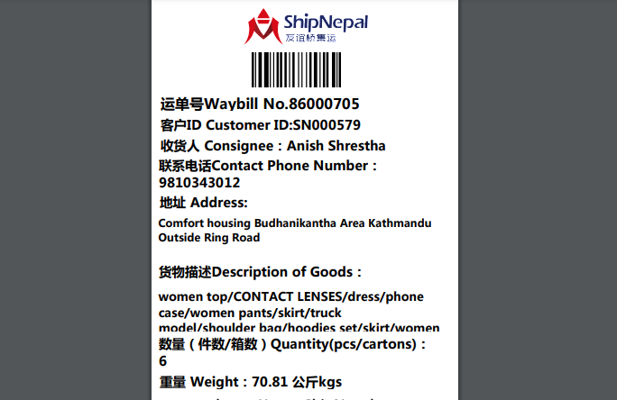

- Shipping mark: POAT, 1 package, case No. 709
Estimated arrival date in Kathmandu: Nov.28, 2024
Deliver to the following, collecting nothing
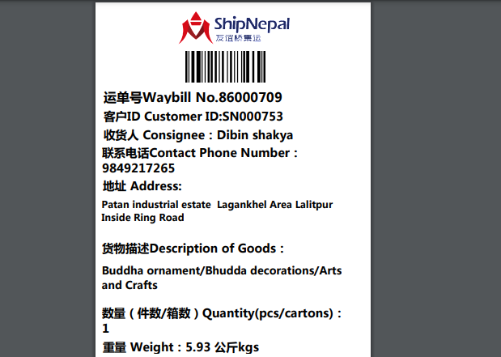
- Shipping mark: MUDP, 1 package, case No. 710
Estimated arrival date in Kathmandu: Dec.3, 2024
Deliver to the following, collecting nothing
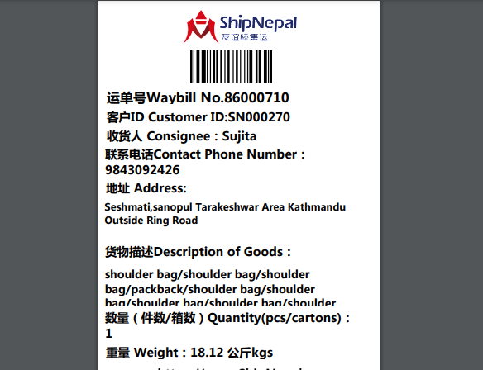

- Shipping mark: SGDP, 1 package, case No. 712
Estimated arrival date in Kathmandu: Dec.3, 2024
Deliver to the following, collecting nothing
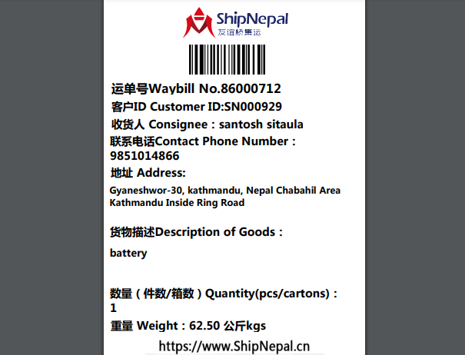
- Shipping mark: MUDP, 1 package, case No. 714
Estimated arrival date in Kathmandu: Dec.5, 2024
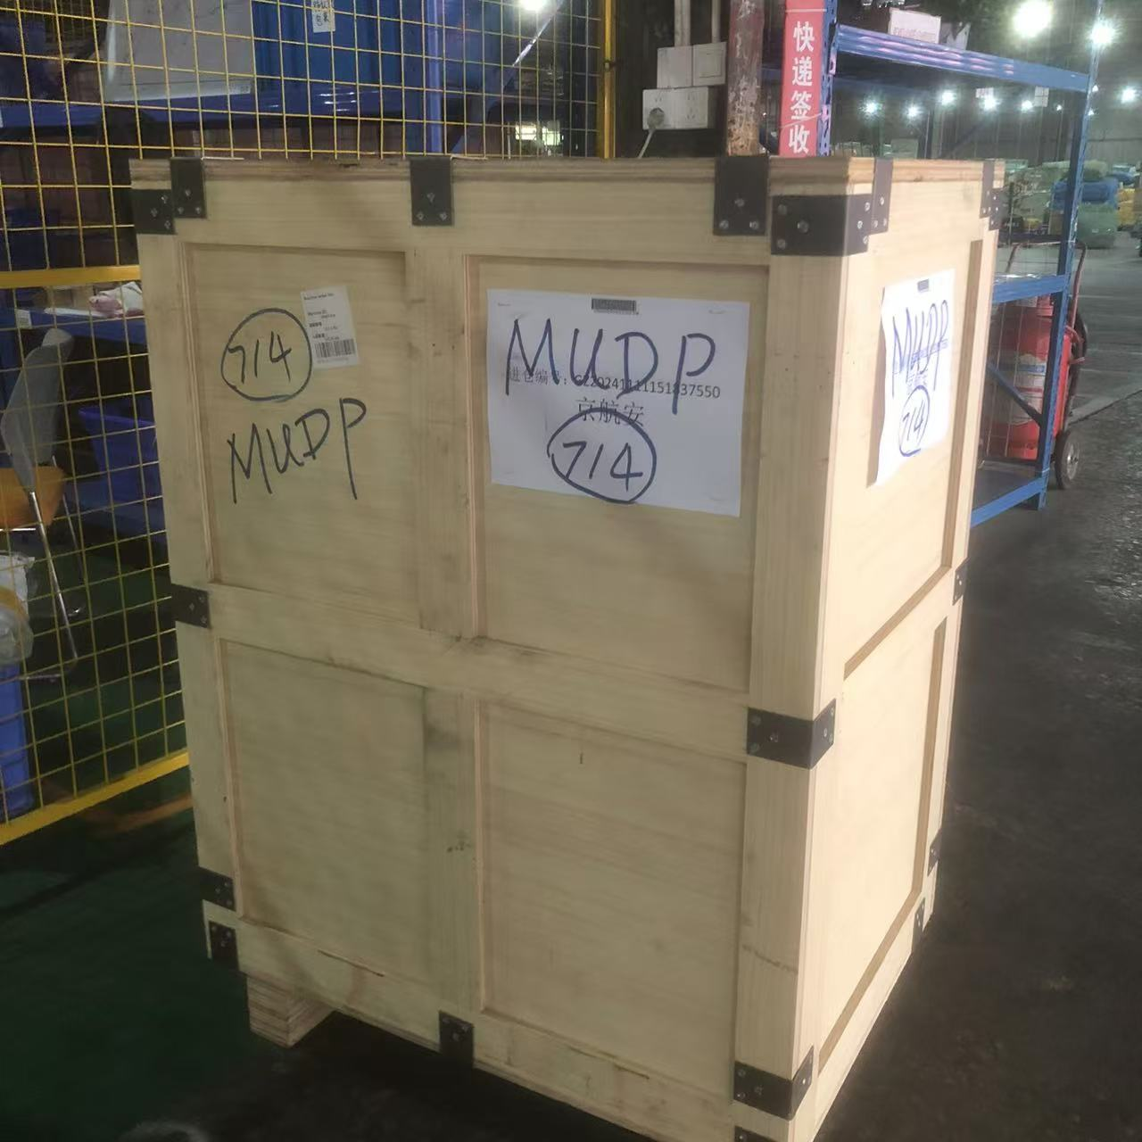
Transship to Porkhara, address as below, collecting nothing, and we (you) pay the local freight from Kathmandu to Porkhara:
Chinne Danda village, Pokhara, Kaski District, Gandaki Zone
Contact: suraj chhetri
Phone: 9779801316741

- Shipping mark: POAT, 2 packages, case No. 715-1-2
Estimated arrival date in Kathmandu: Nov.30, 2024
Deliver to the following, collecting nothing
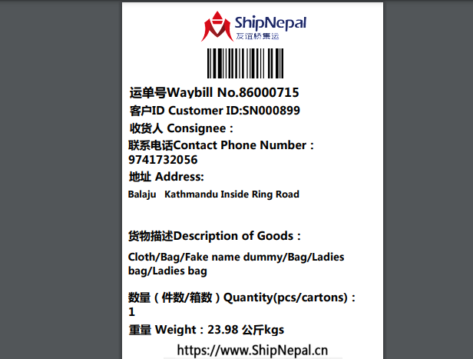

- Shipping mark: UMDP, 11 packages, case No. 716-1-11
Estimated arrival date in Kathmandu: Dec. 8, 2024
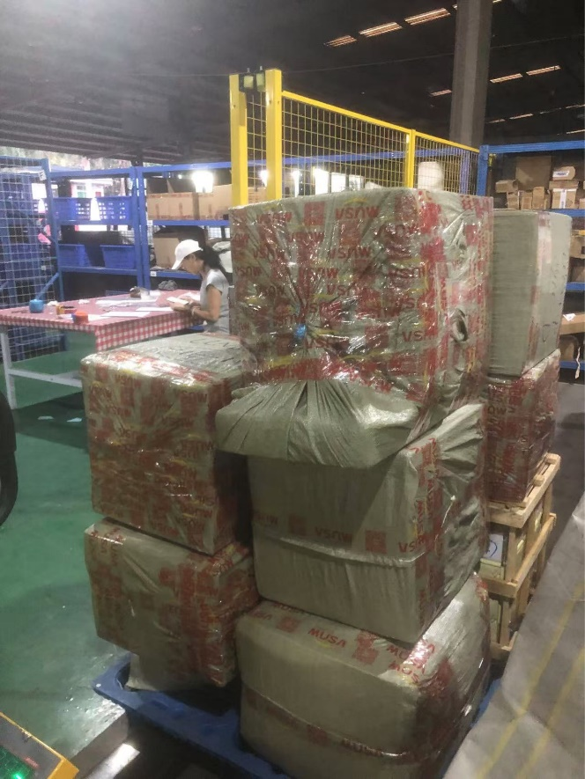 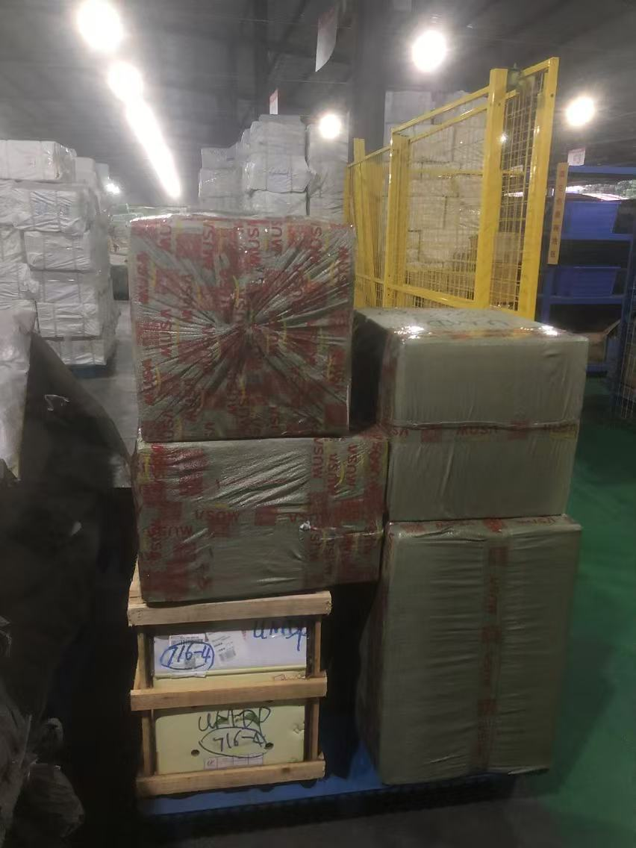274kgs; 11 packages
Transshipped to Porkhara, collecting customs fees before picking-up
- Shipping mark: UMDP, 1 package, case No. 716-12
Estimated arrival date in Kathmandu: Dec. 8, 2024
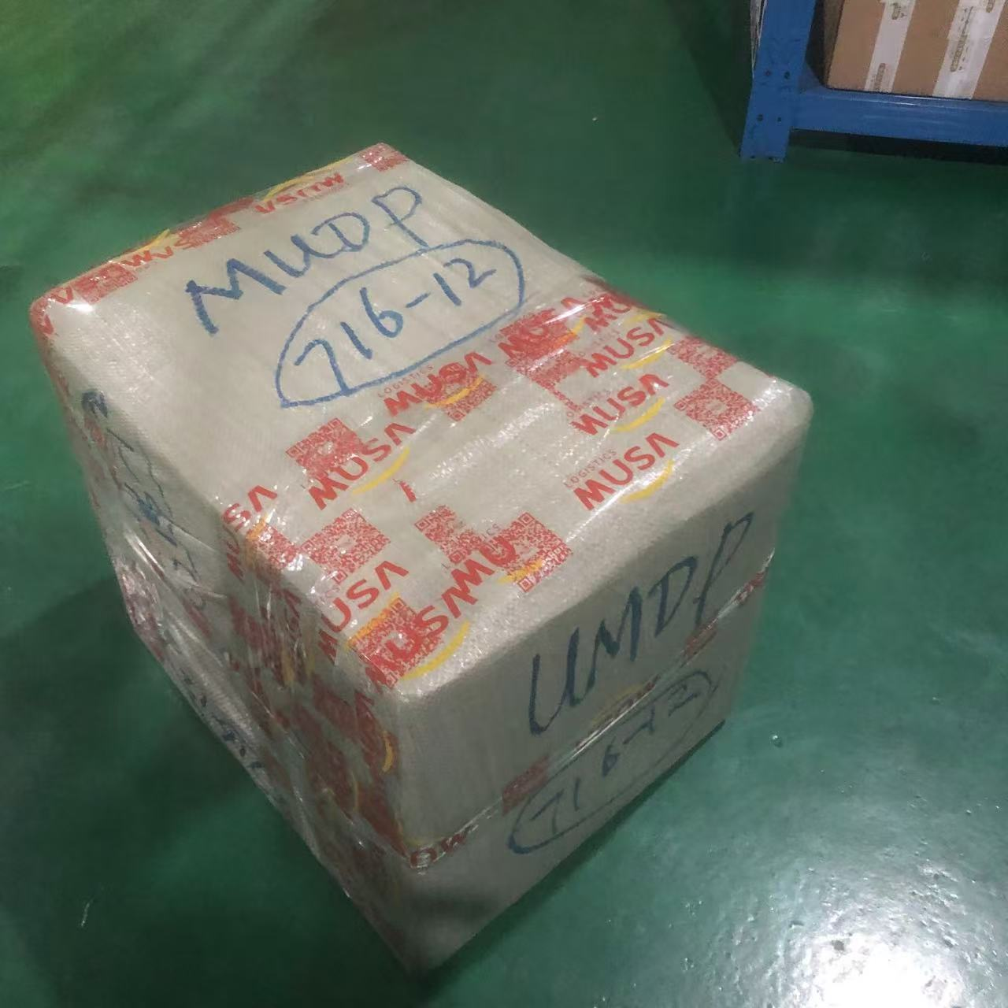
Open the package above , shown as below:
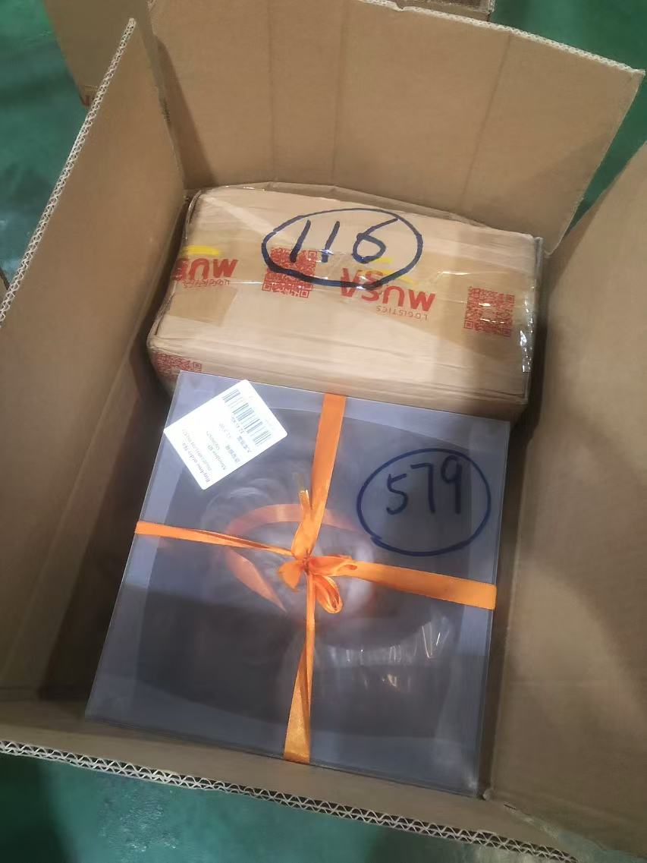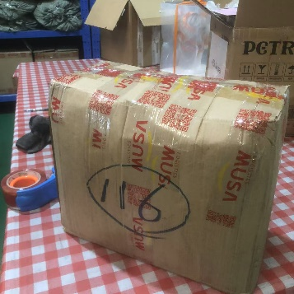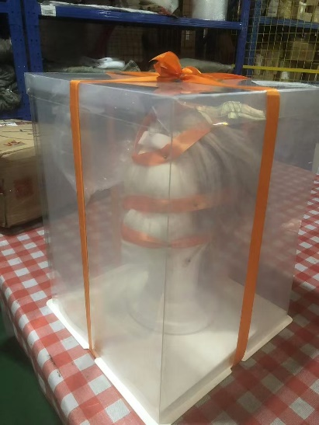

Taking out the semi-transparent plastics box marked 579 and deliver to the following, collecting nothing
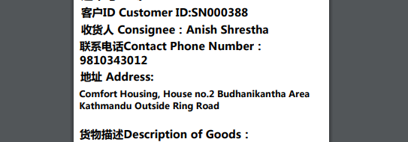

Transship the carton marked 116 to Porkhara, all expenses from KTM to Porkhara on us, to the following, collecting nothing:
